**Phase5: Testing in DevOps LifeCycle**

**By: Suruchi S Rajguru**

**Github repository link:** https://github.com/SuruchiRajguru/Suruchi-Phase5-NikunjShah.git

**Project 1: CI/CD Deployment for Springboot Application**

**Steps to automate the integration & deployment of the web application are as follows.**

Login to LMS Account🡪Go to Practice Labs🡪AWS🡪Launch lab🡪AWS Web Console🡪Auth Url

AWS Management Console will appear on screen 🡪

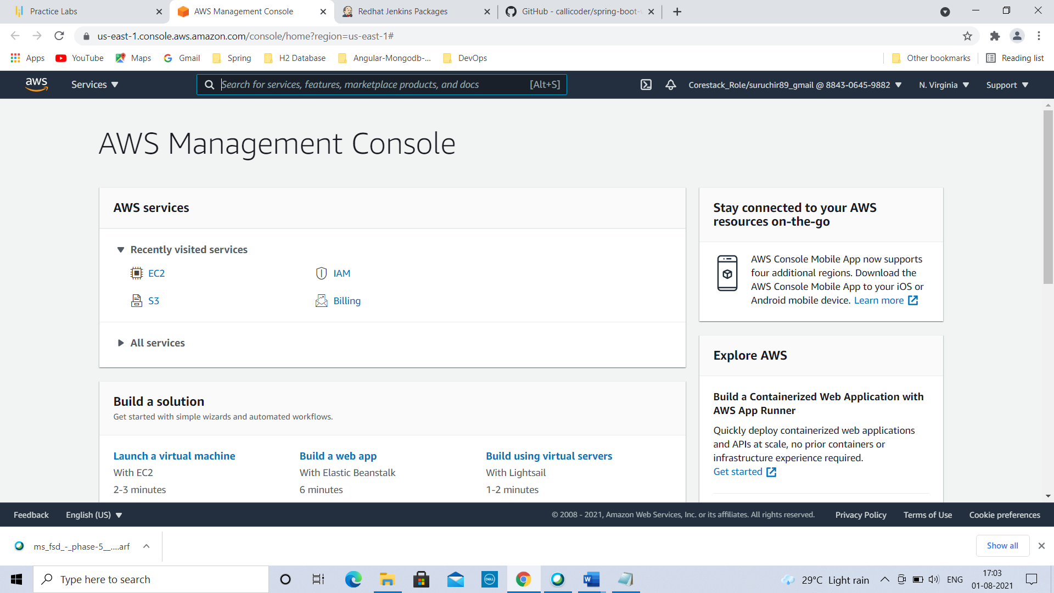

Go to AWS Services🡪 Click on EC2🡪

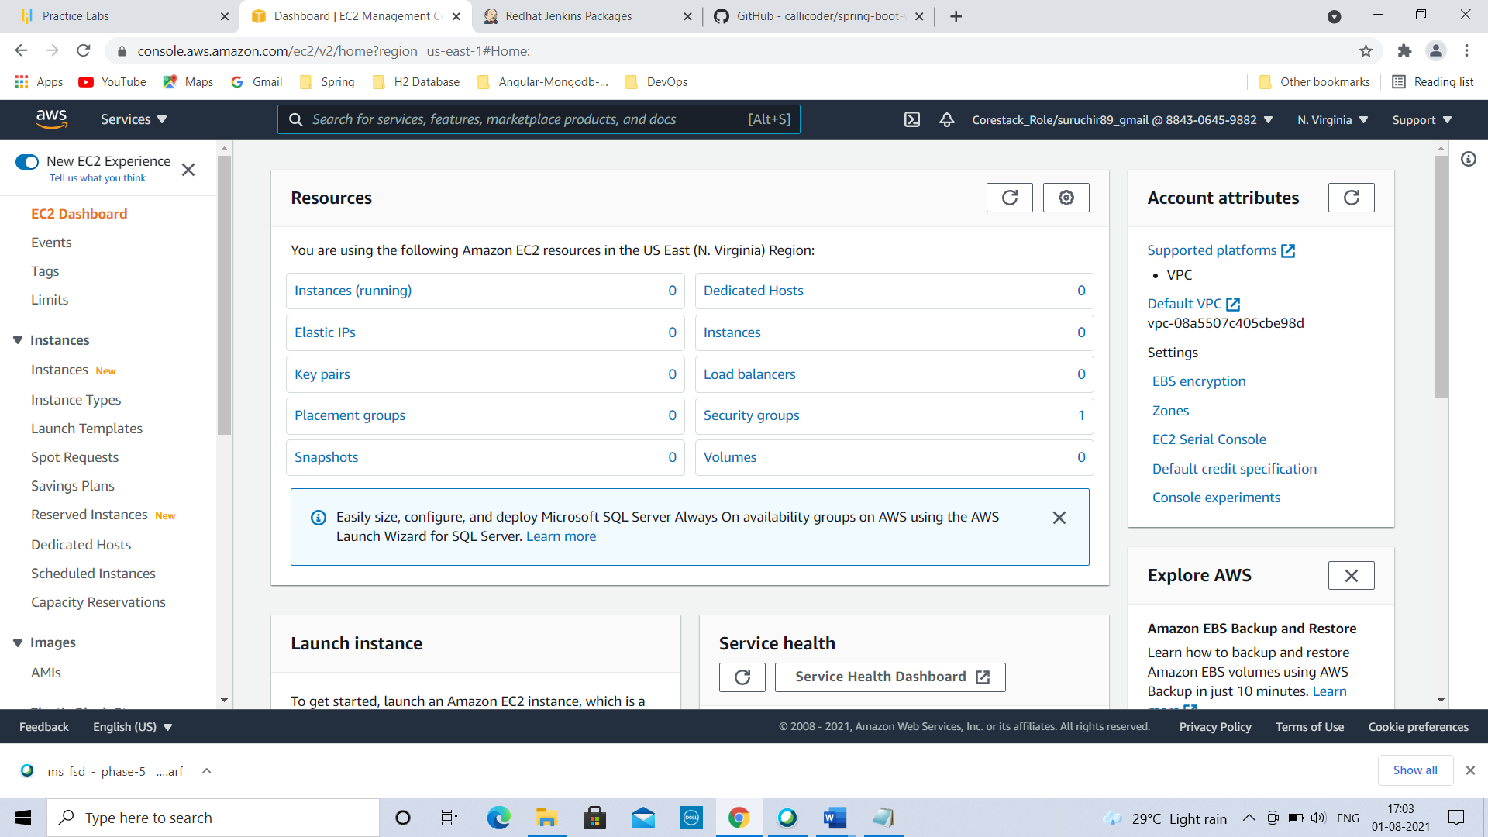

Scroll down & go to Launch instance🡪

To get started, launch an Amazon EC2 instance, which is a virtual server in the cloud.

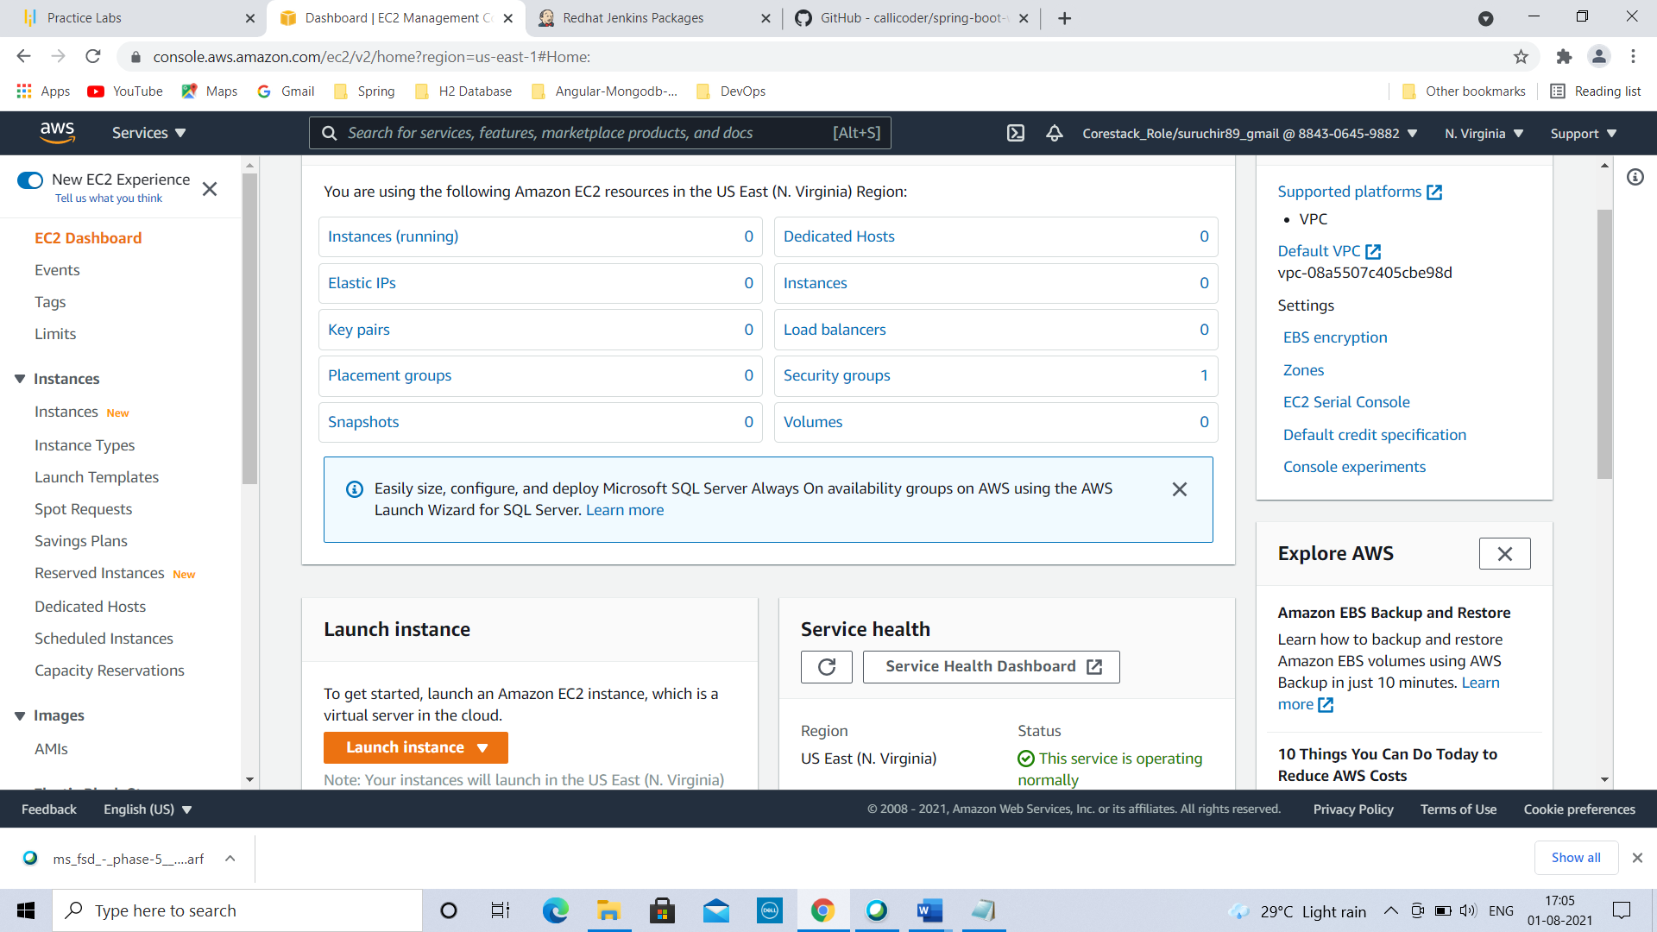

Click on Launch instance dropdown-->click on Launch instance.

Step 1: Choose an Amazon Machine Image (AMI)

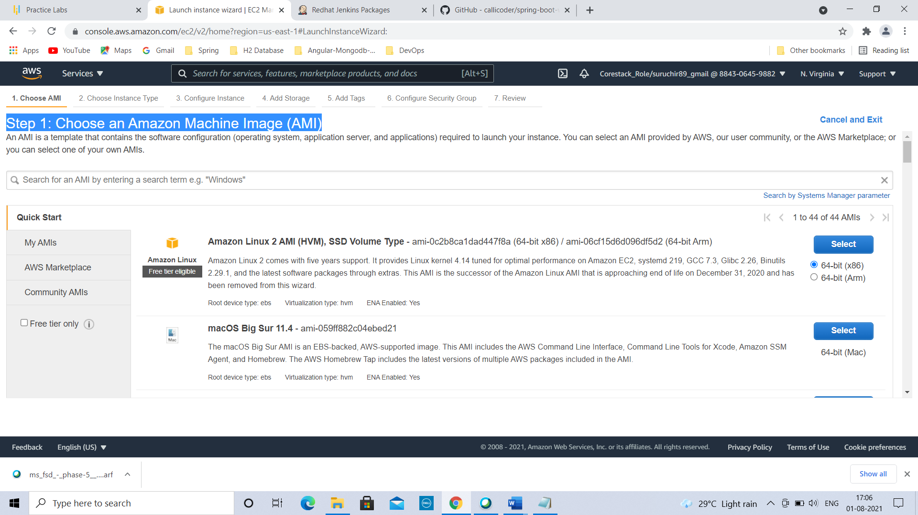Select Amazon Linux 2 AMI(HVM), SSD Volume Type🡪

Step 2: Choose an Instance Type

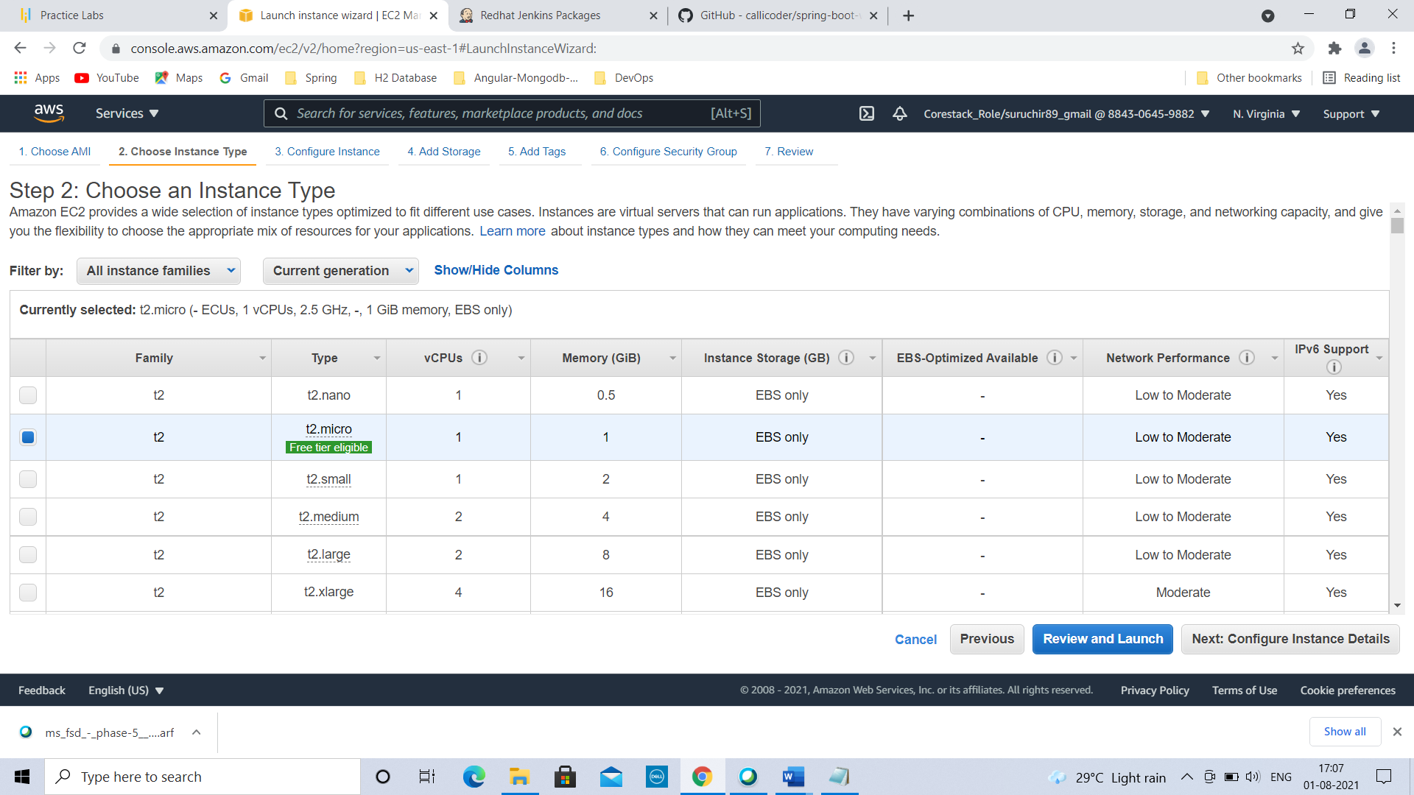

Select t2.micro (Free tier eligible) type 🡪Click on Next: Configure Instance Details🡪

Step 3: Configure Instance Details

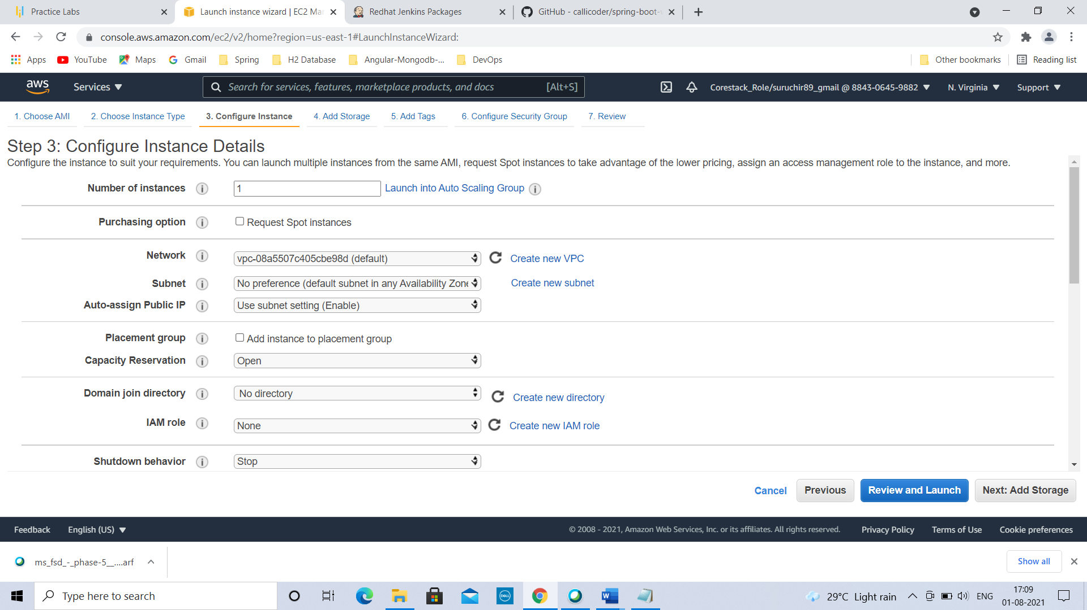

Click on Next: Add storage🡪

Step 4: Add Storage

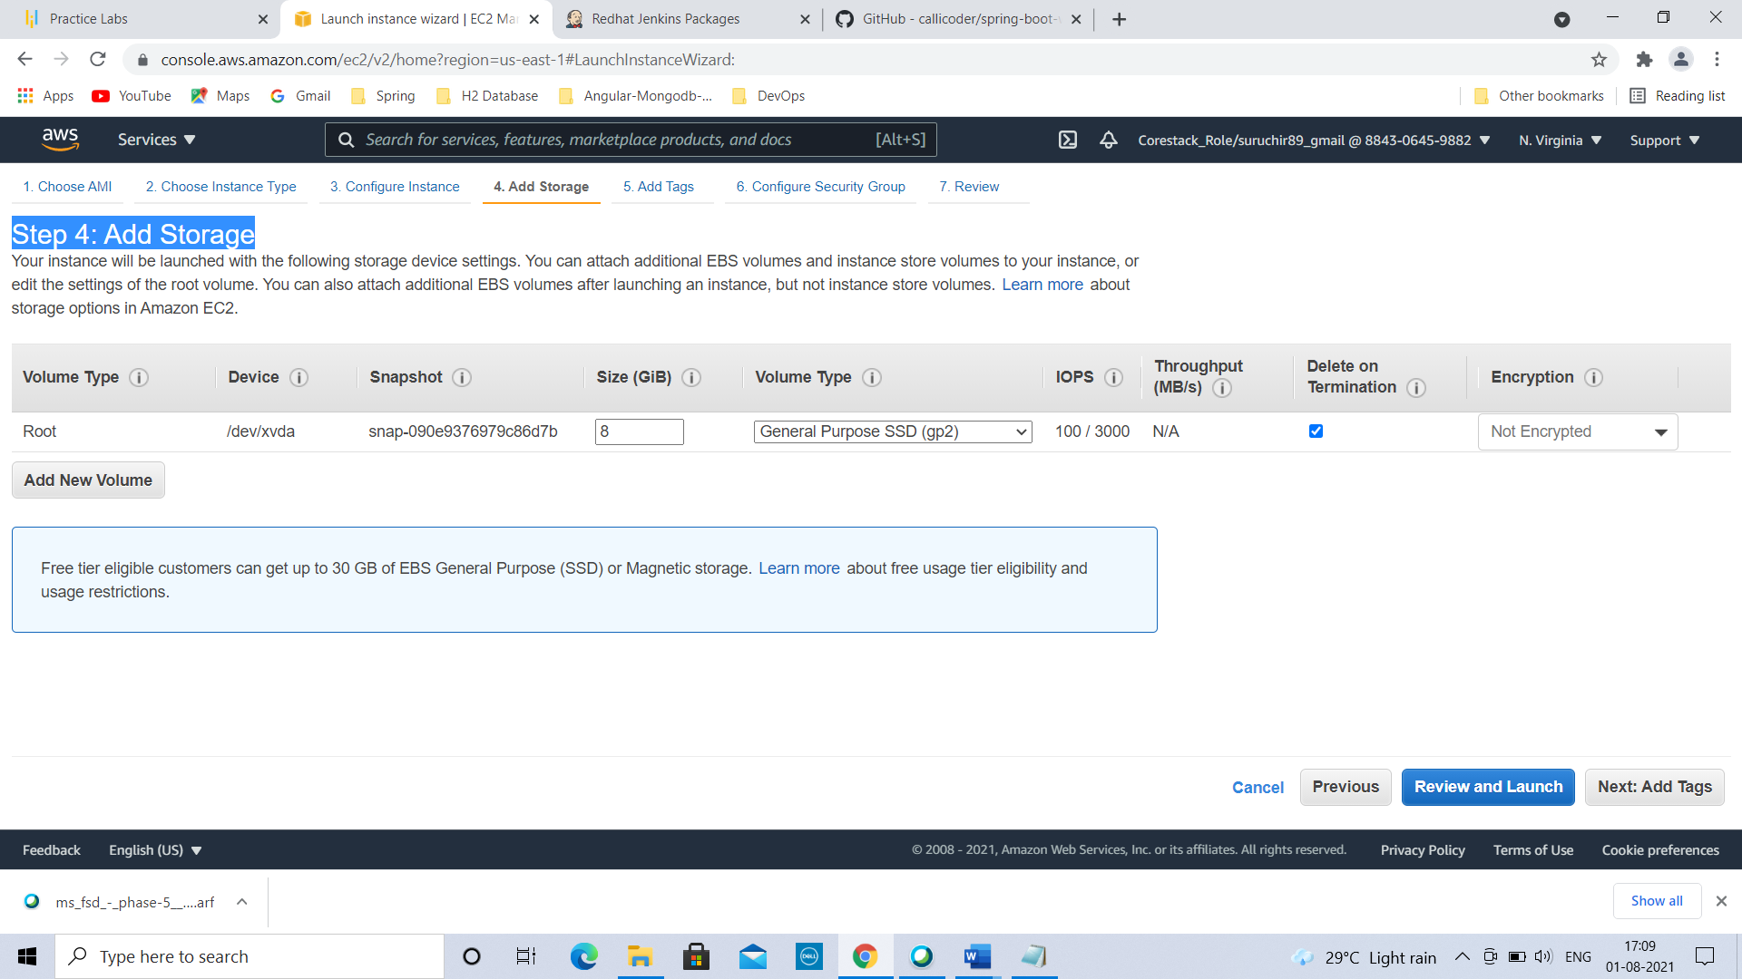

Click on Next: Add Tags🡪

Step 5: Add Tags

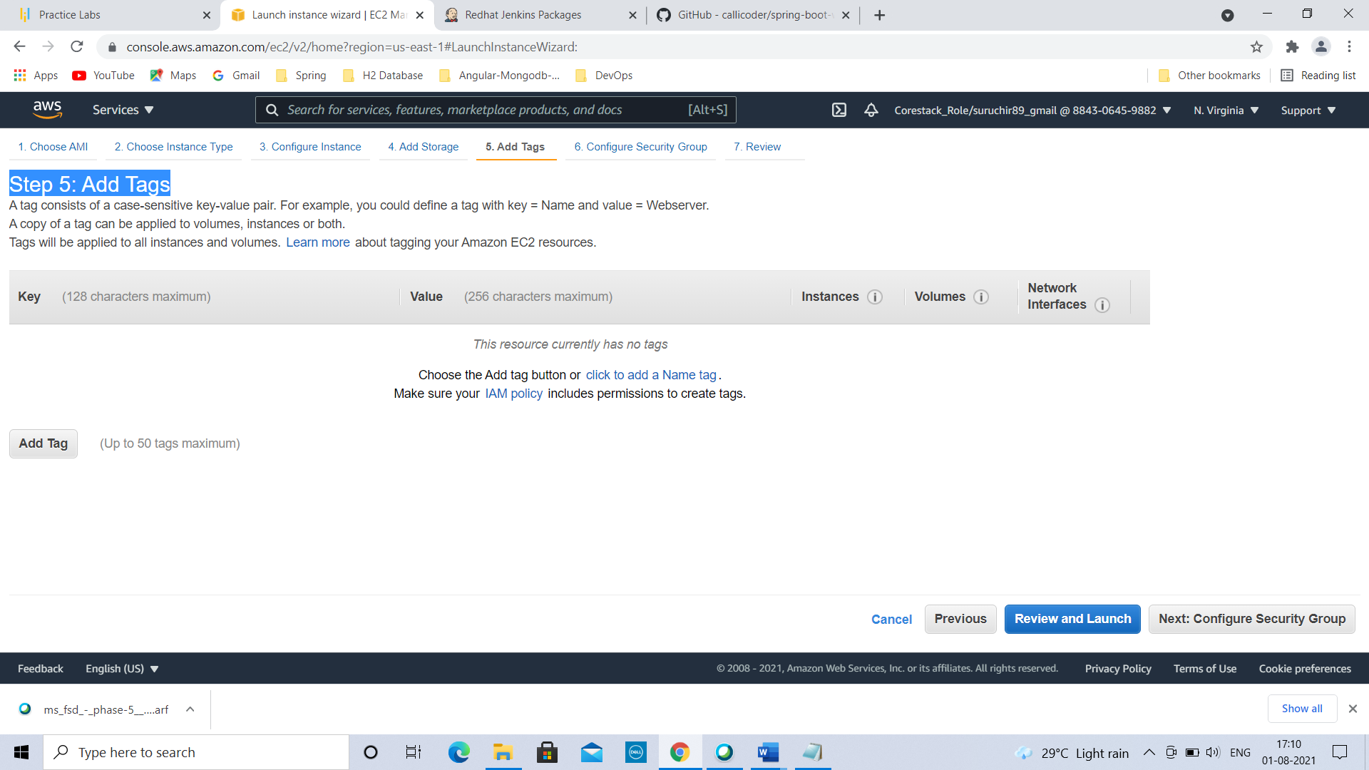

Click on Next: Configure Security Group🡪

Step 6: Configure Security Group

Click on Add Rule button

Set Type from SSH to All Traffic

Set Source from custom to Anywhere

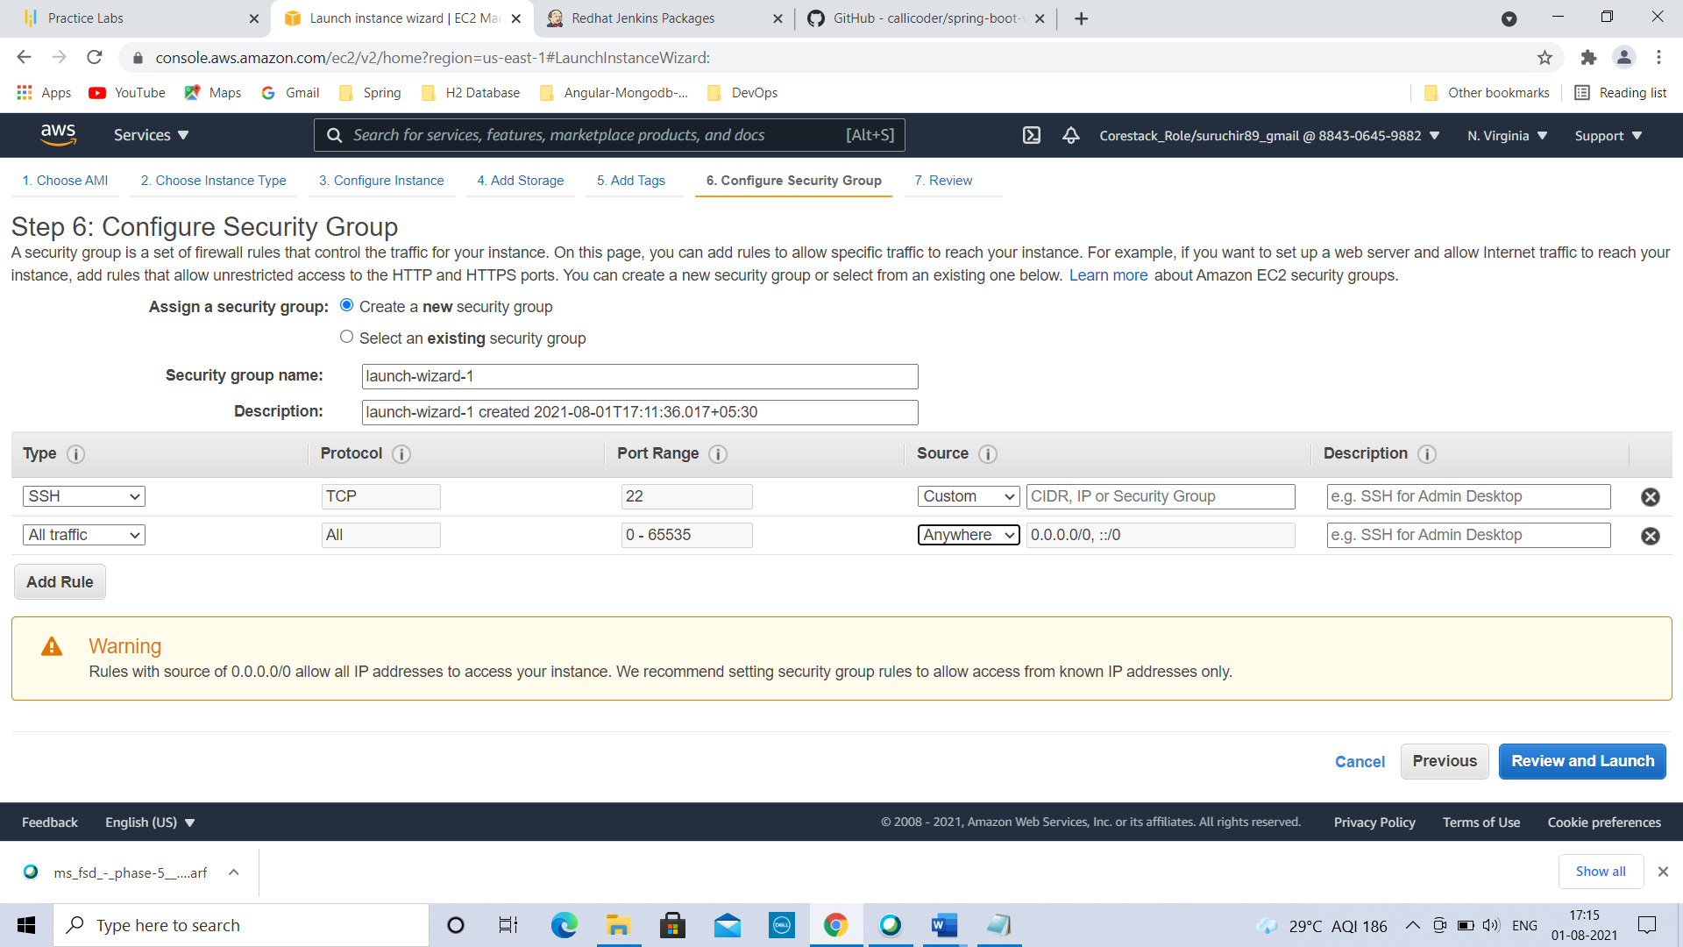

Click on Review and Launch🡪

Step 7: Review Instance Launch

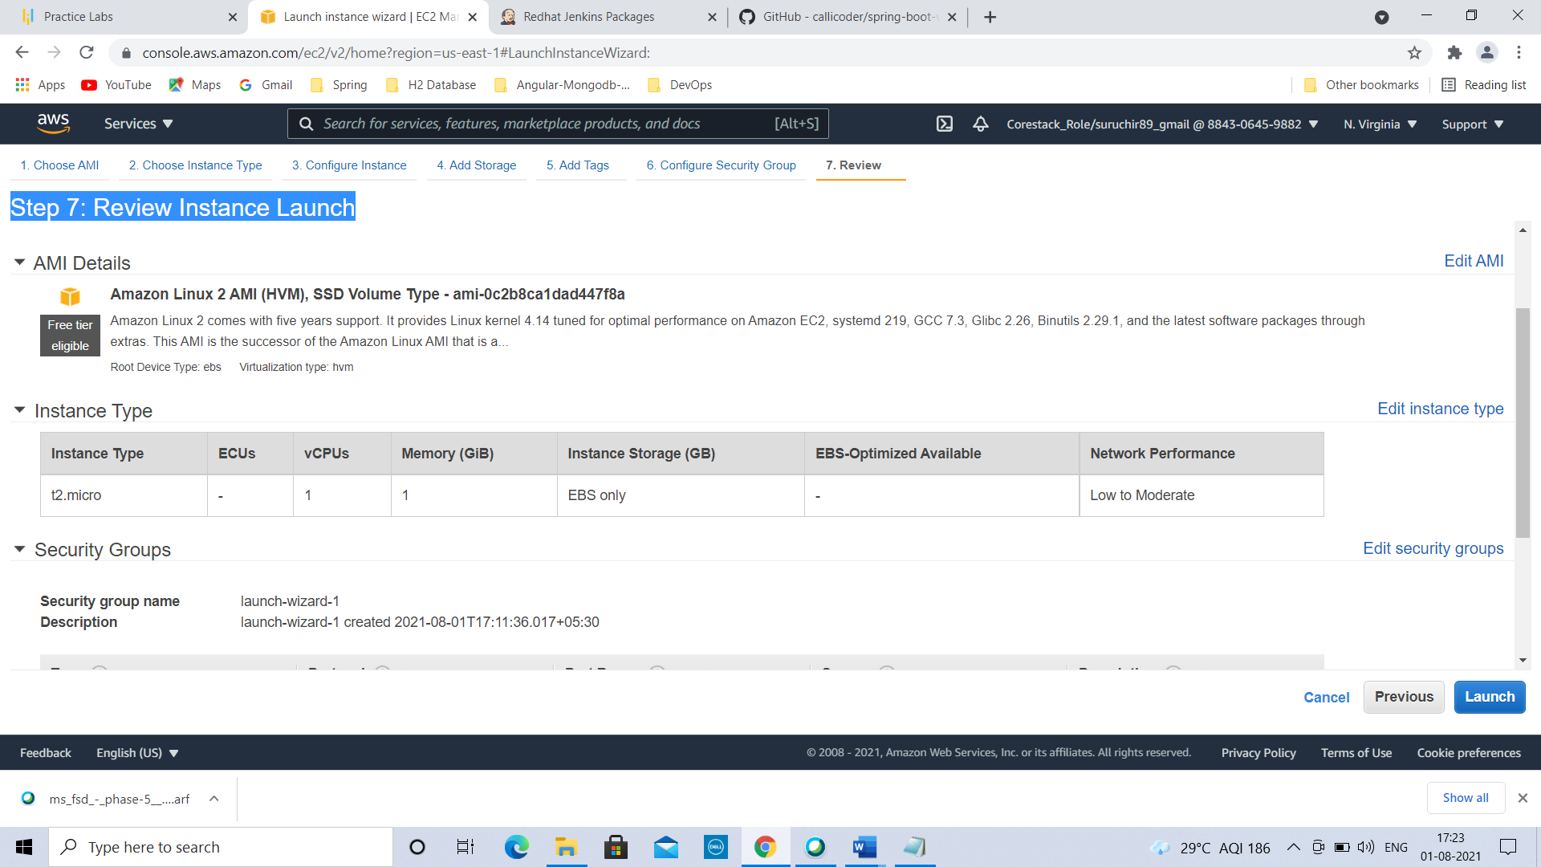

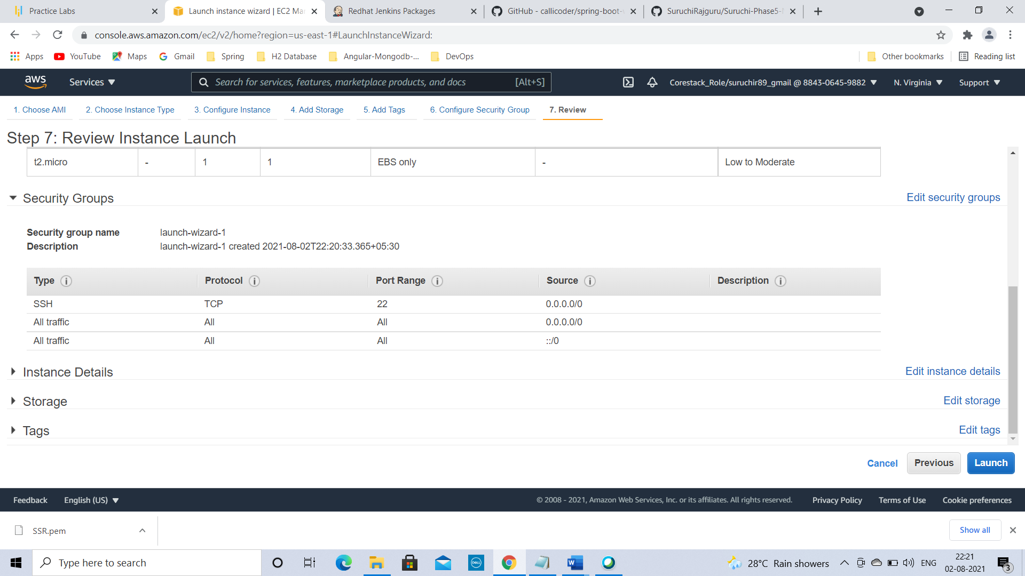

Review all steps by scrolling down & then Click on Launch🡪

Select an existing key pair or create new key pair

Select existing key pair or create new key pair from drop down box🡪give key pair name🡪Download key pair before clicking on Launch instance🡪key will be stored in your System at appropriate location.(Default Downloads folder)

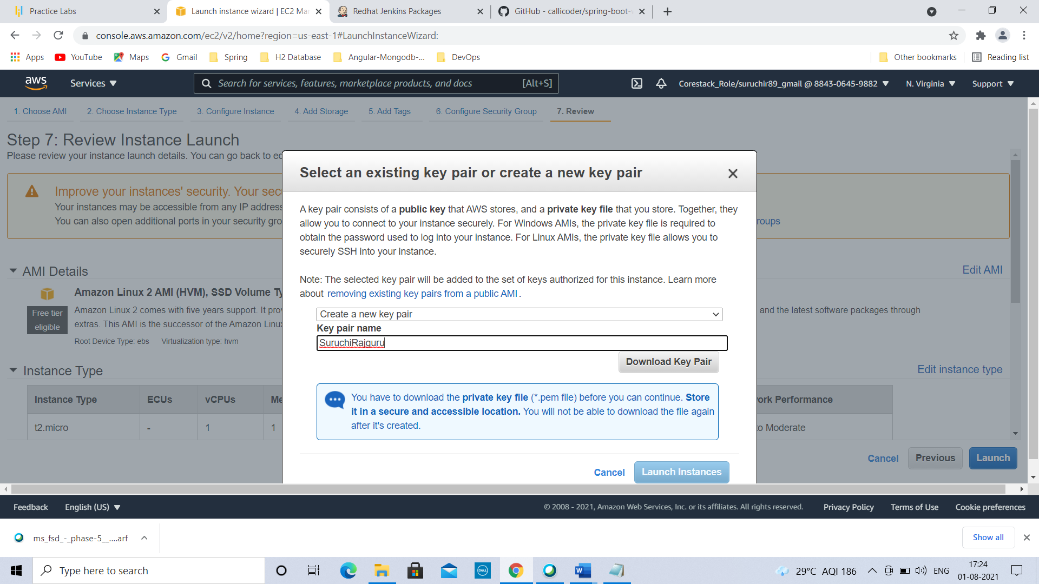

Click on Launch Instances🡪

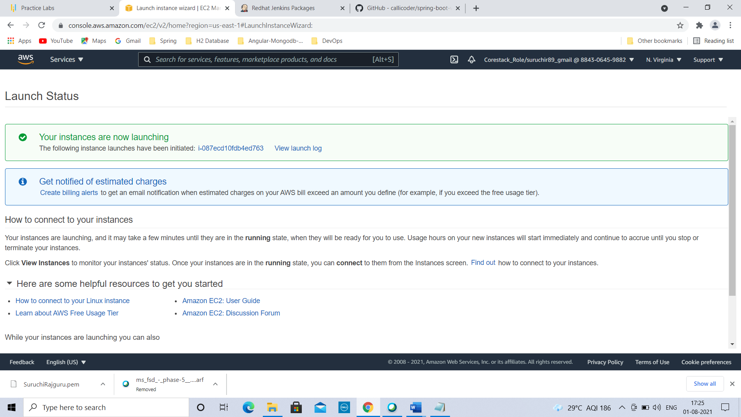

Click on instance id🡪

You are on EC2 Instance now🡪

Check Instances(1)—one instance is created 🡪check instance state as running🡪

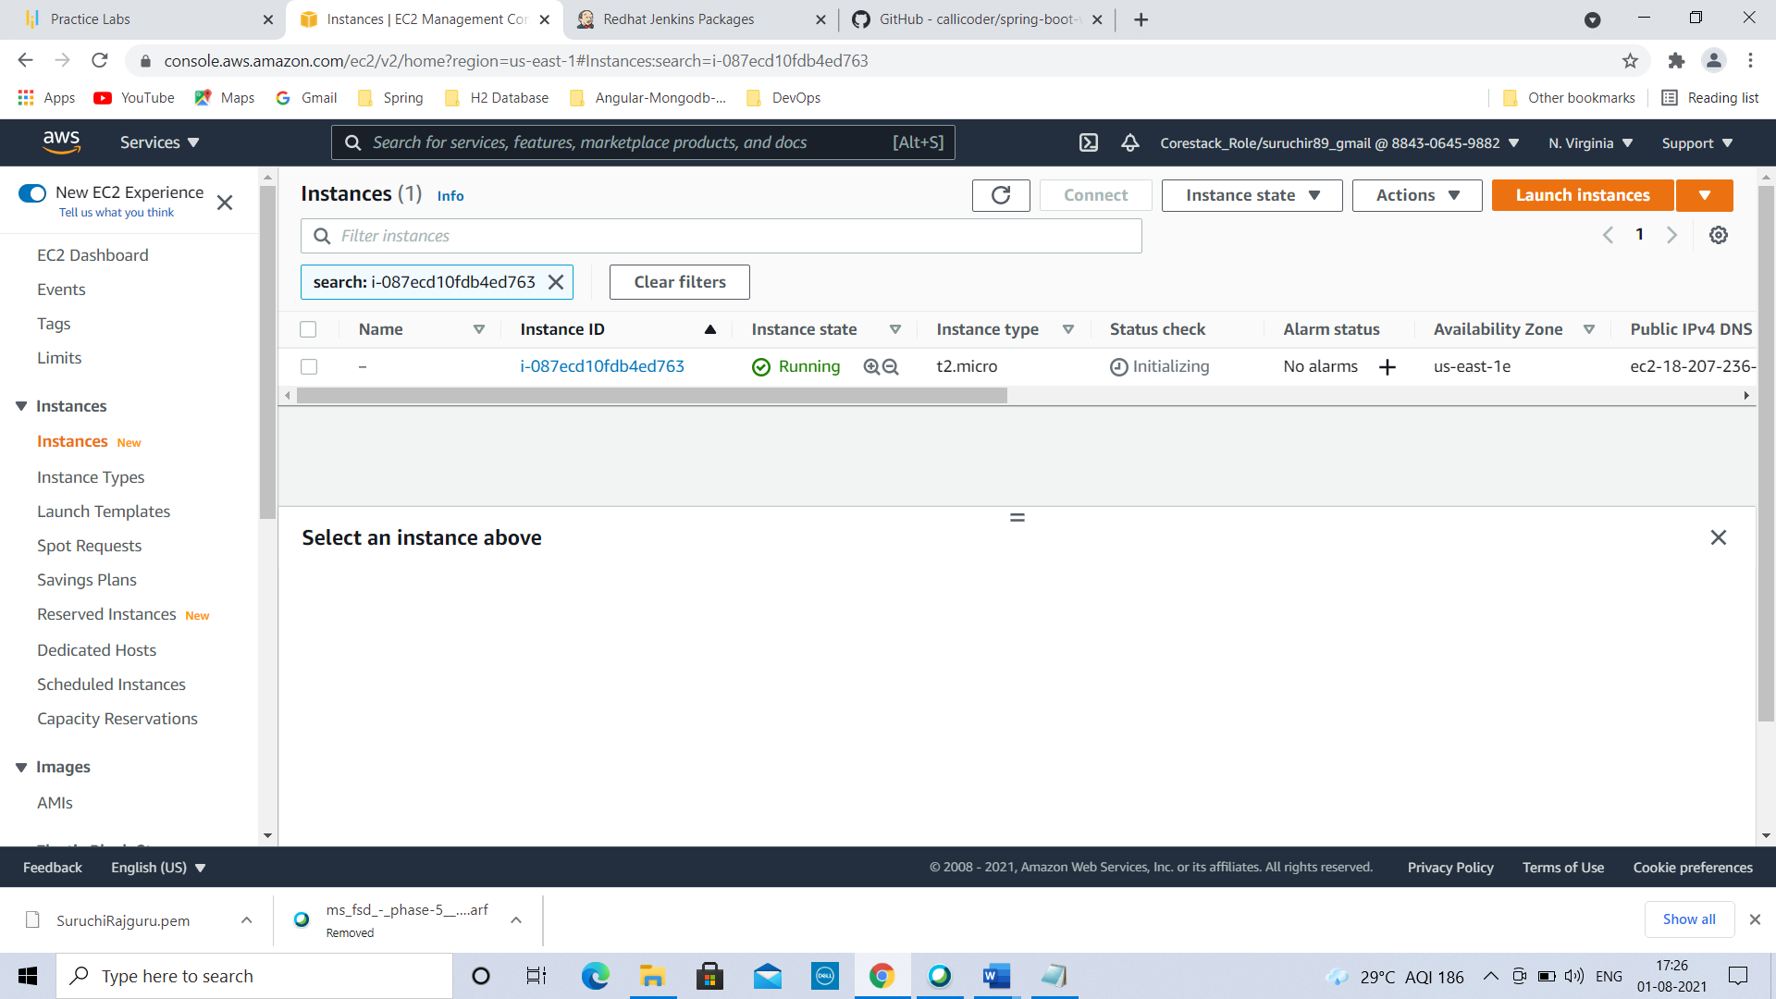

Click on Instance ID🡪Instance summary for created instance is visible here🡪Click on connect🡪

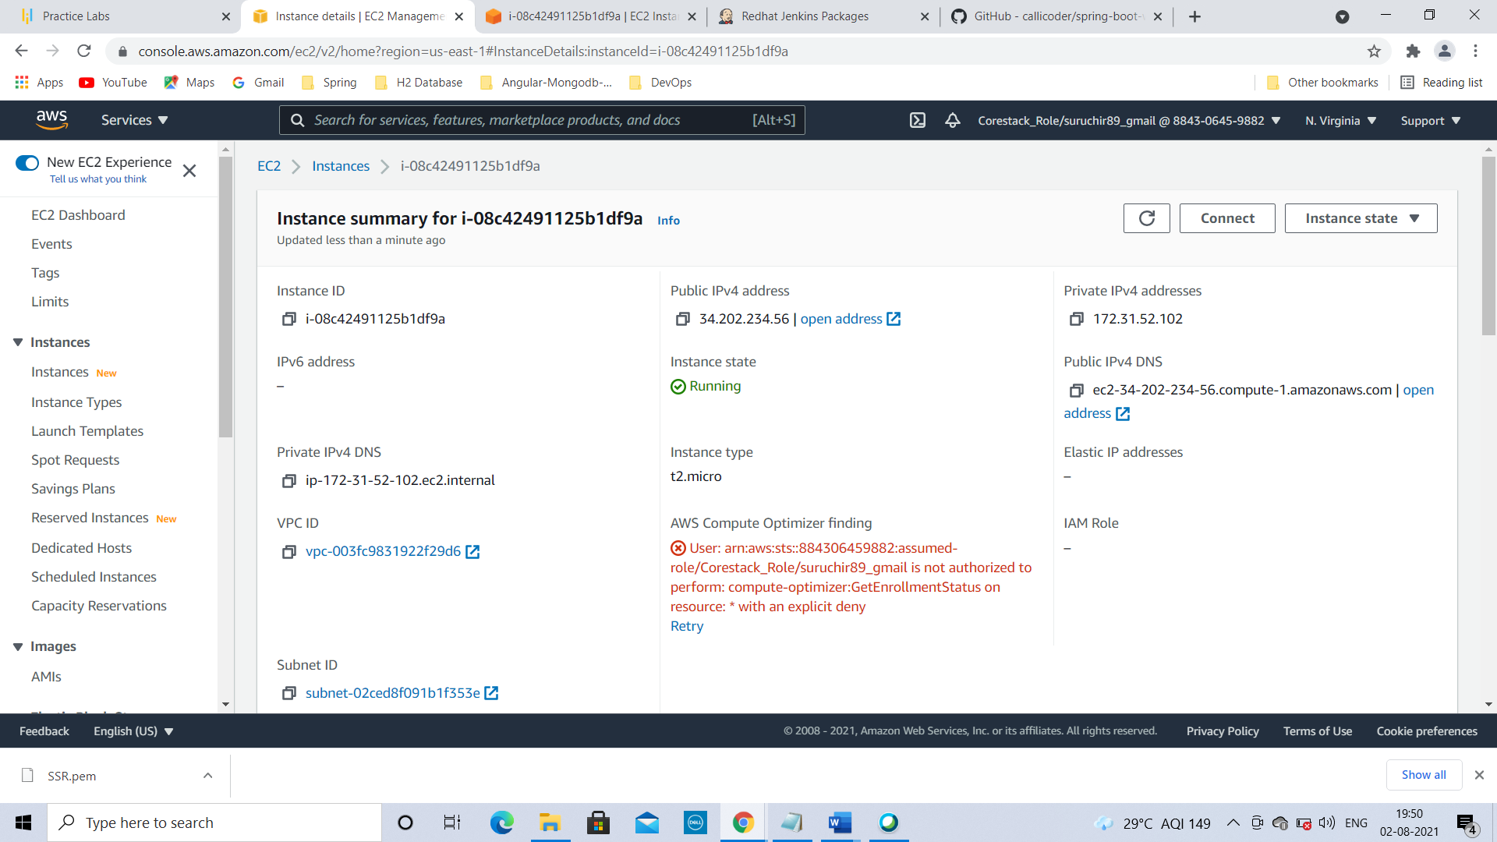

Go to SSH client🡪

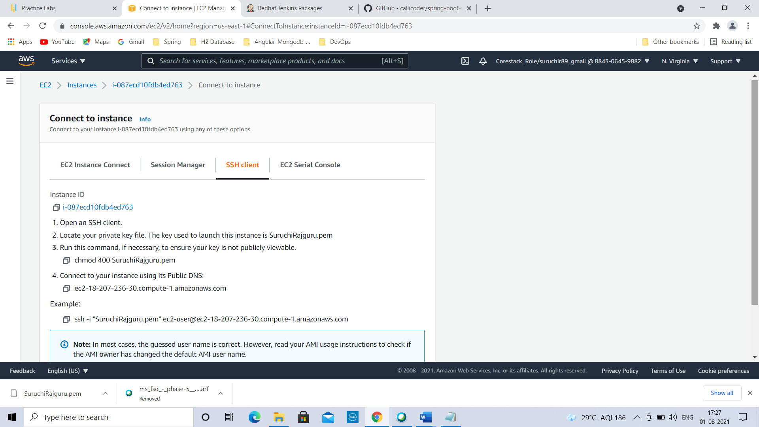

Copy ssh Key🡪

Open command prompt from location where .pem file is stored(Go to downloads folder & from there open command prompt)🡪copy ssh key & press enter🡪

You are connected to the EC2 Instance now.

Click on EC2 Instance Connect

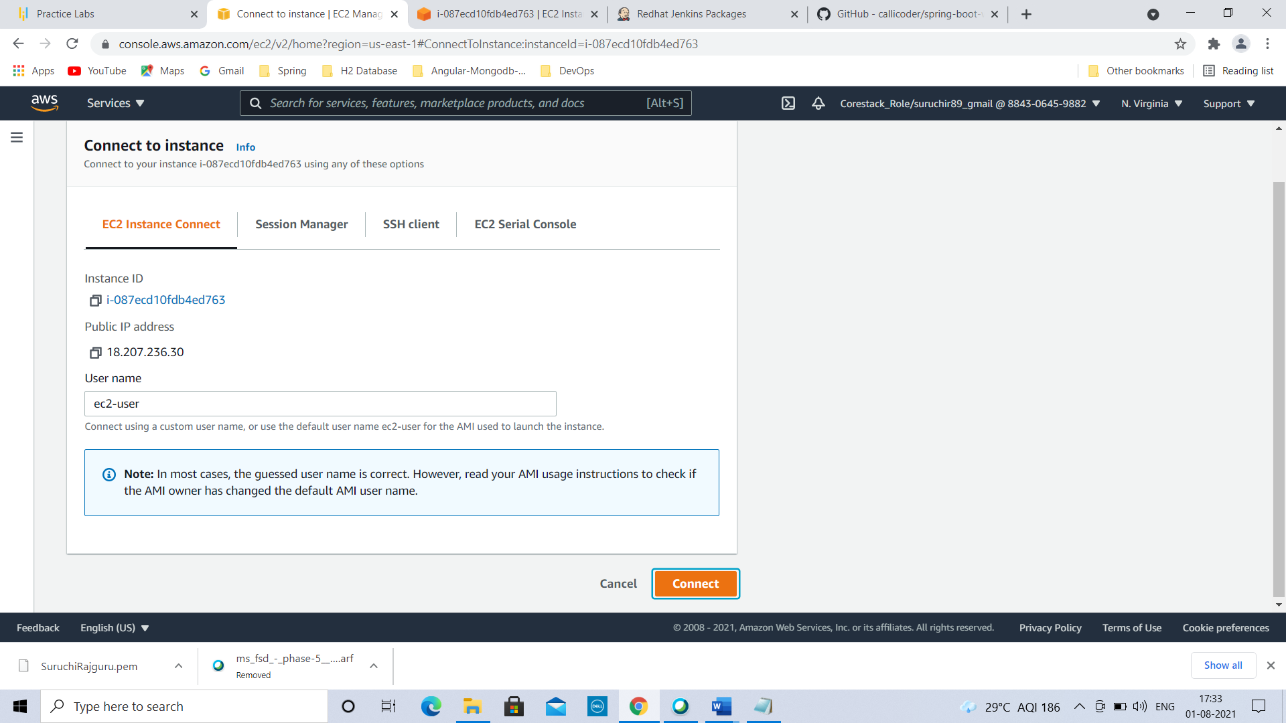

Click on connect

You are on EC2 instance now

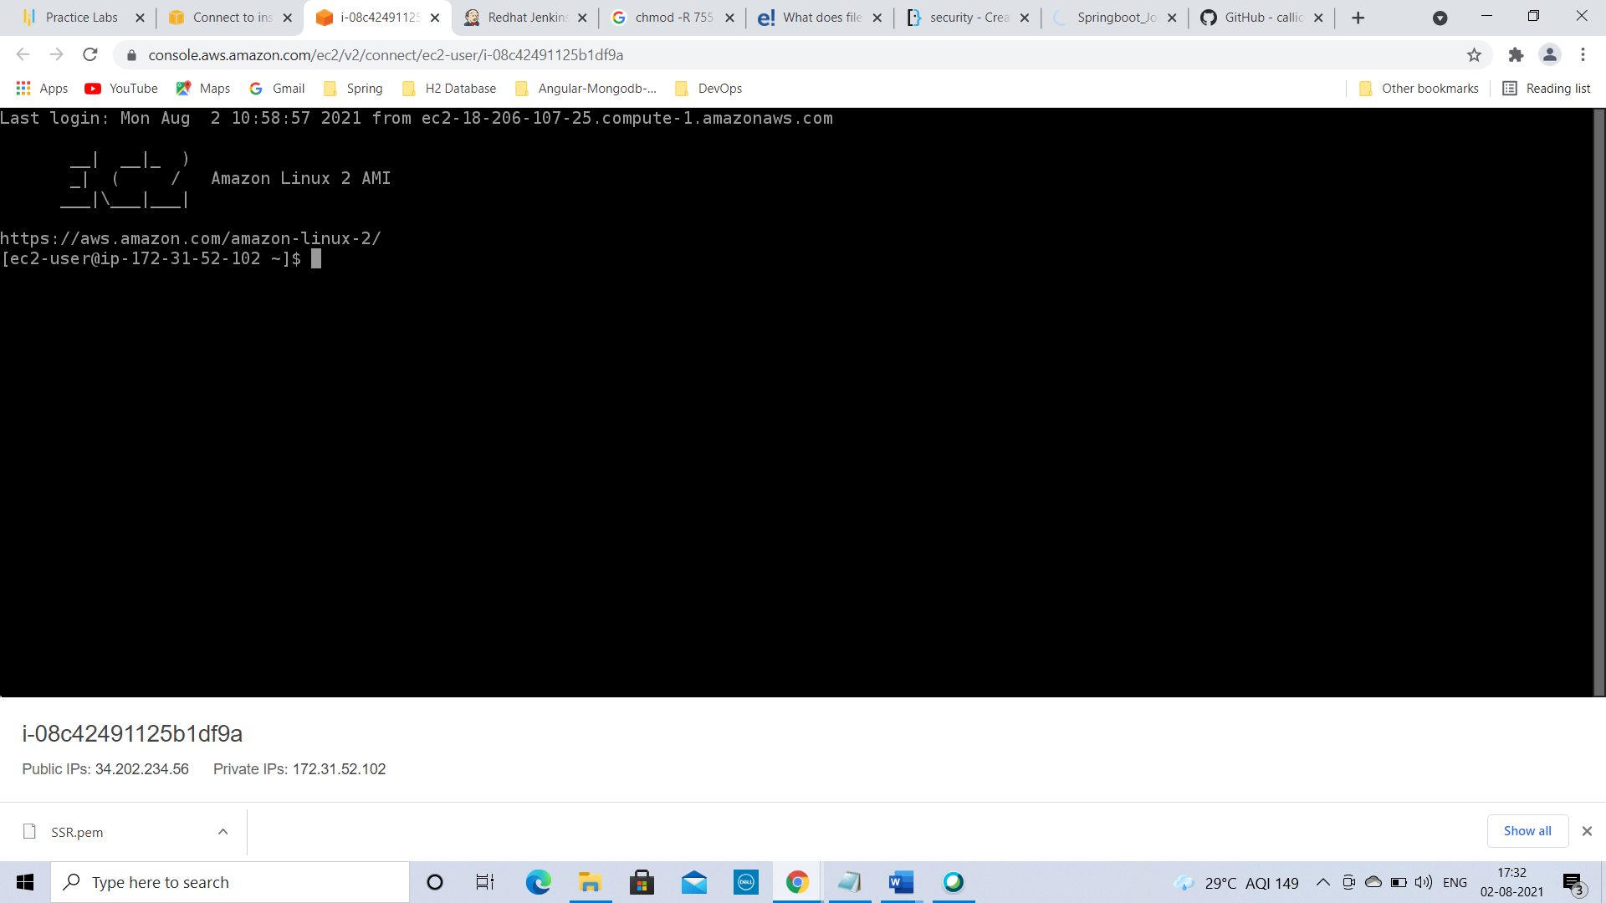

To become a root user, type command in command prompt:

sudo -i you will become a root user now

Execute following commands

1. yum update -y updates packages

To install git, type:

1. yum install git -y success message: complete

To install maven,type:

1. yum install maven -y success message: complete

To check Maven version, type:

1. mvn -version displays Maven Version, Path

To clone the repository from Github, type:

1. git clone <https://github.com/callicoder/spring-boot-websocket-chat-demo.git>

To list files or directories,type:

1. ls displays spring-boot-websocket-chat-demo inside it

Move into project spring-boot-websocket-chat-demo using,

1. cd spring-boot-websocket-chat-demo

To clean the package & load the project

1. mvn clean package cleans the package & loads the project 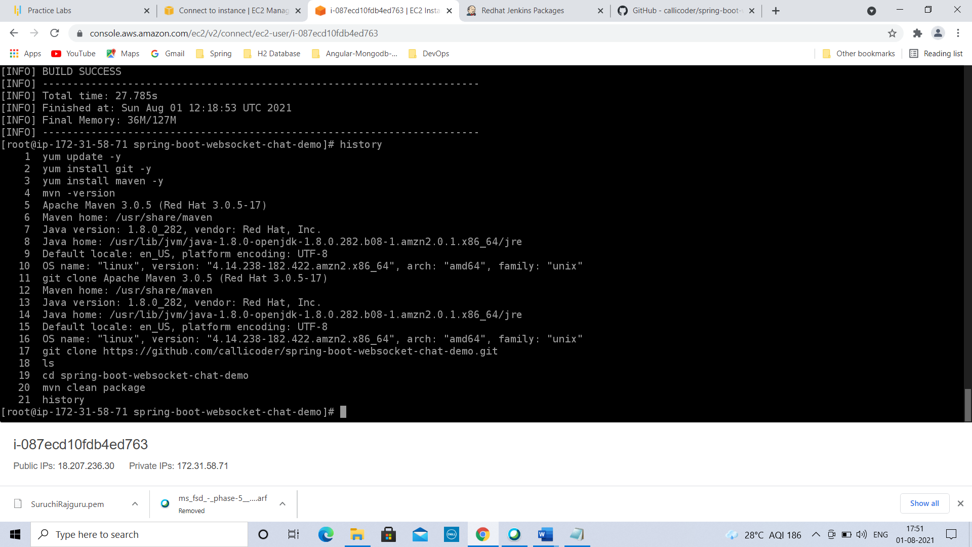

To install docker, type:

1. yum install docker -y complete

To start the docker, type:

1. systemctl start docker

To check docker images,

1. docker images

To build new docker image, type:

1. docker build -t springbootimage .

To check image creation, again type:

1. docker images

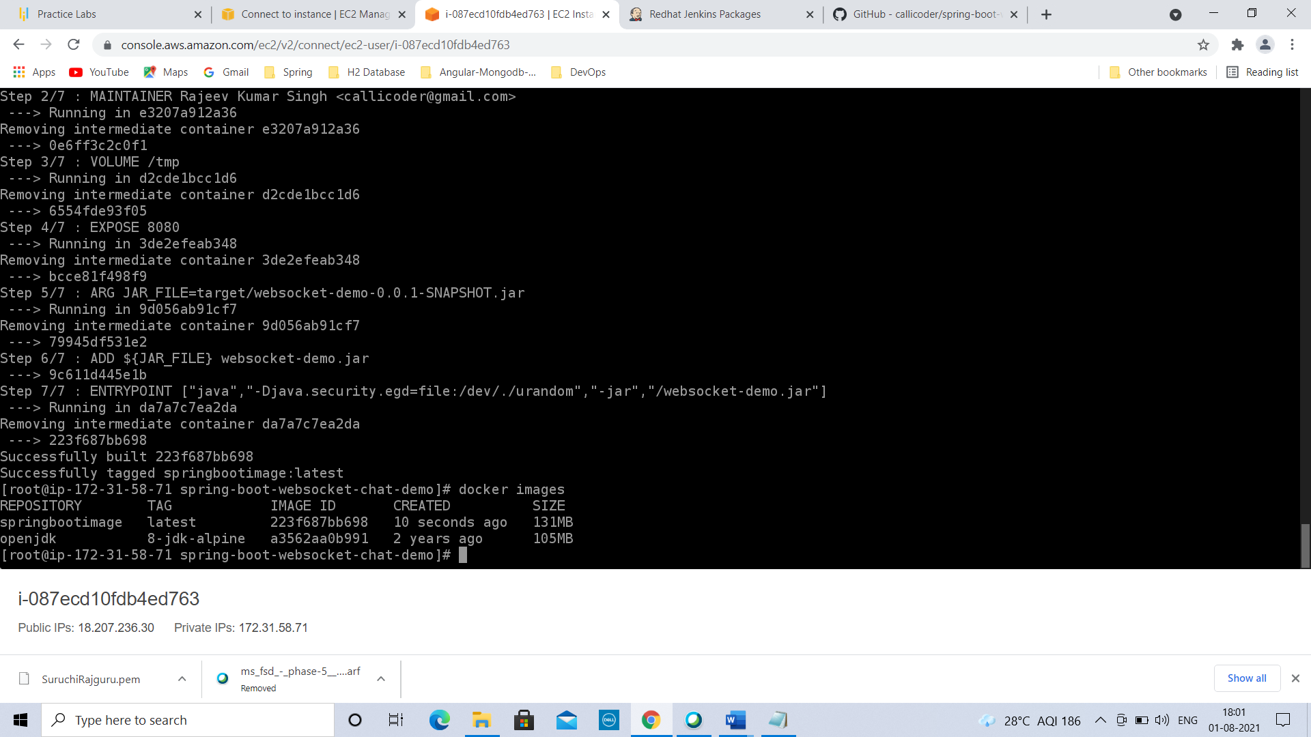

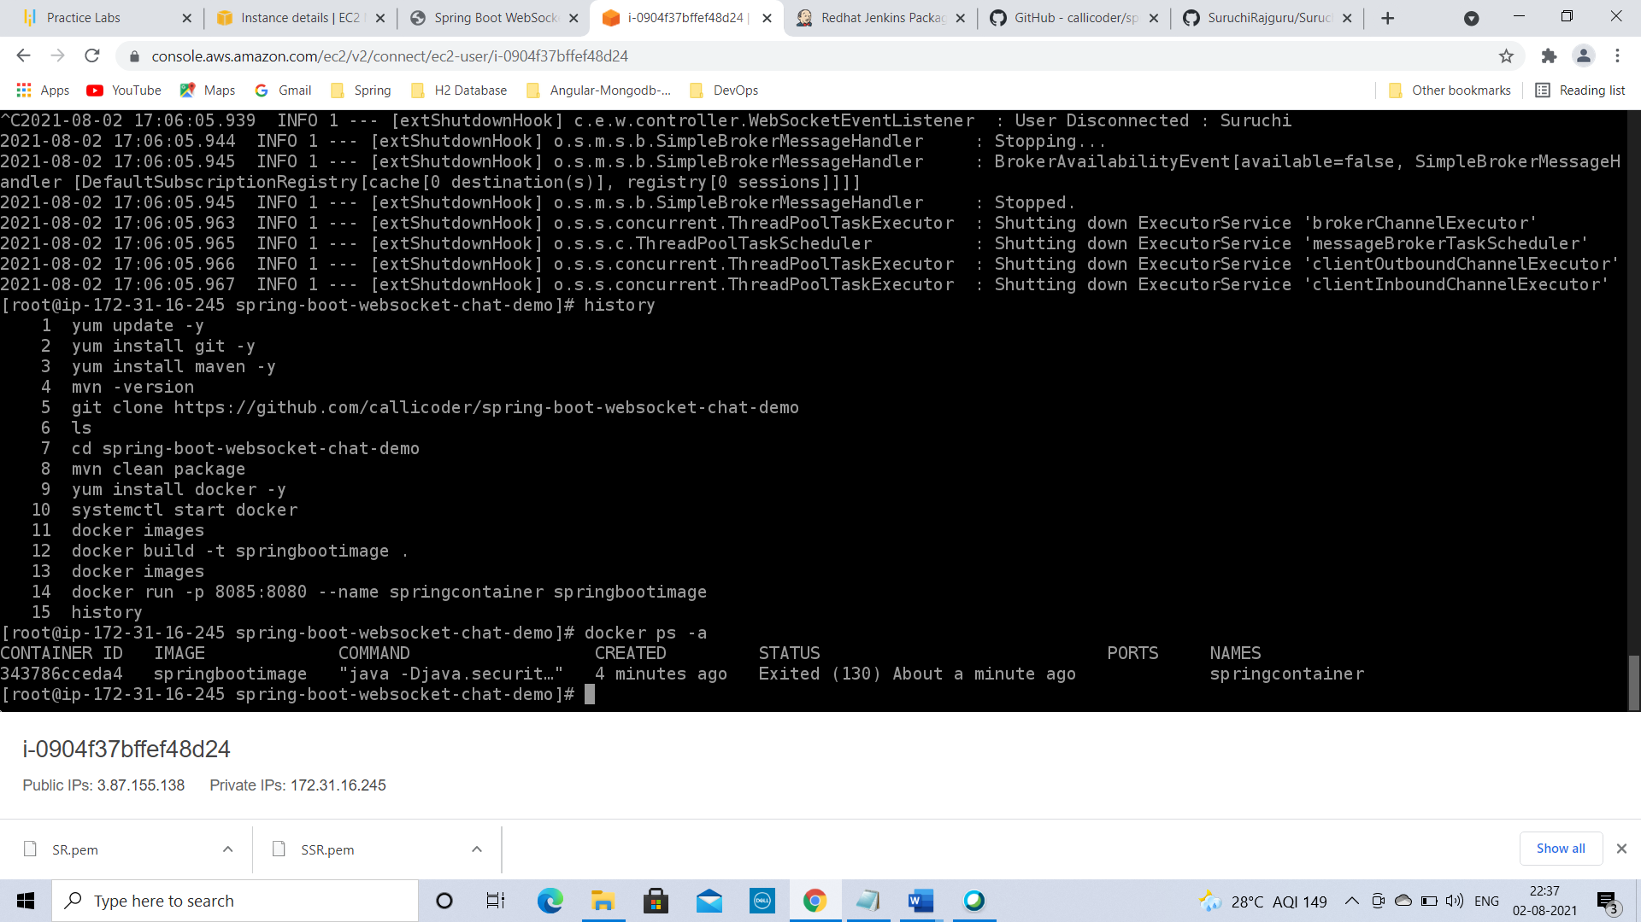

sprinbootimage is created 🡪

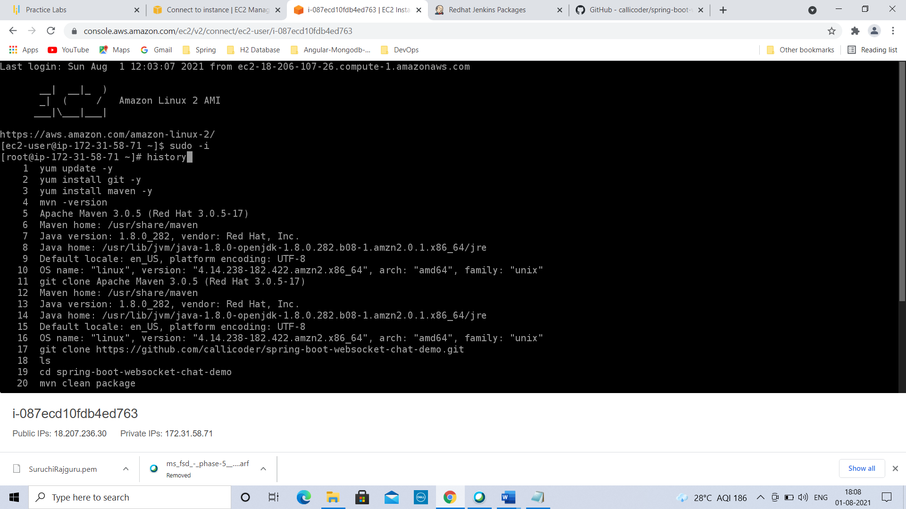

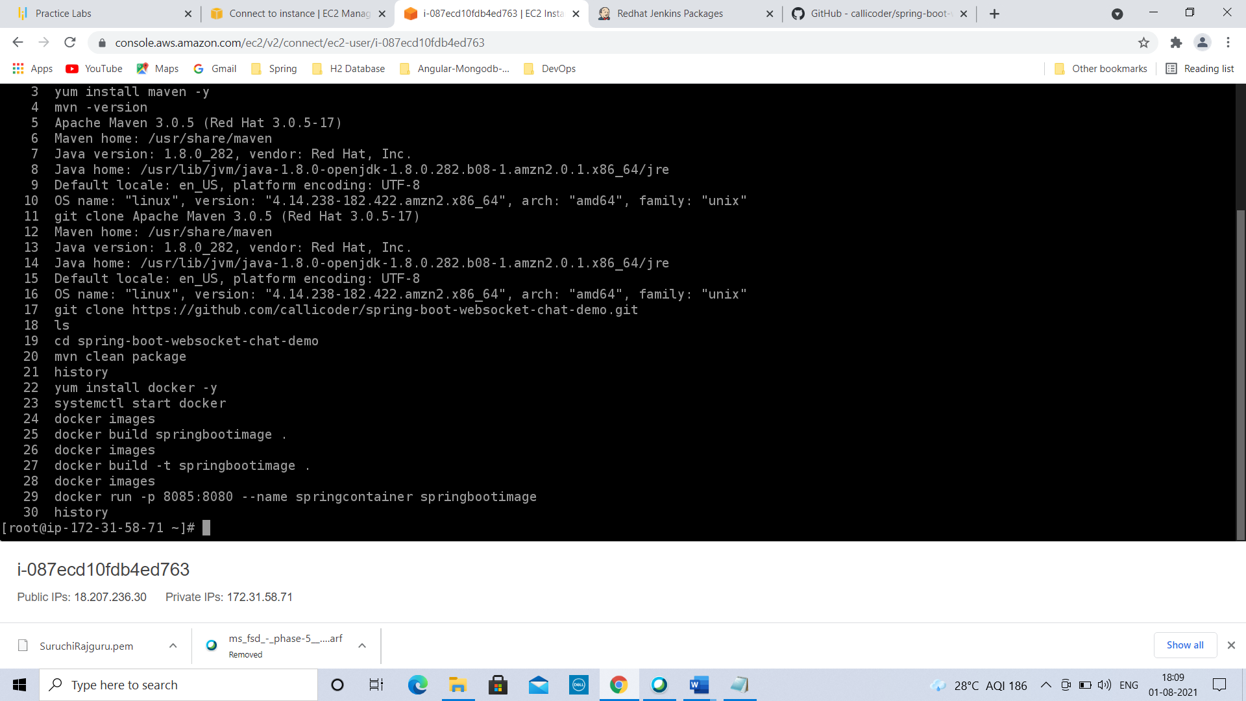

To create the container from the image

1. docker run -p 8085:8080 - -name springcontainer1 springbootimage

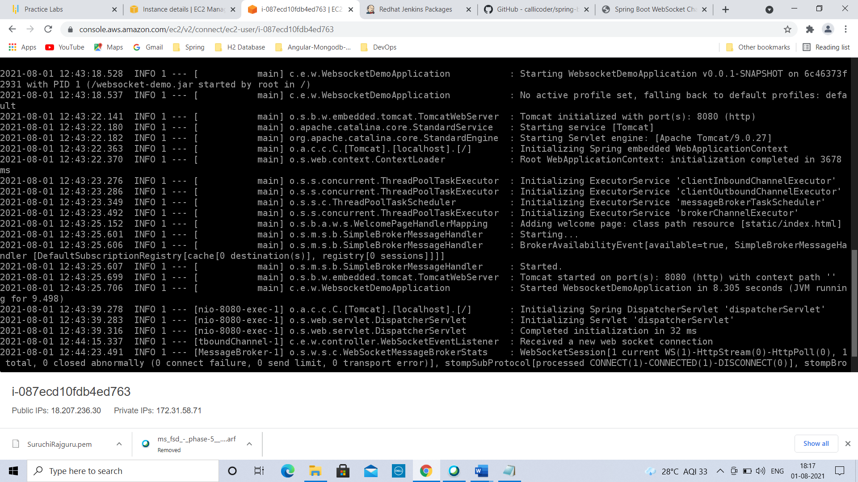

Go to Instance summary & check Public IPV4 address

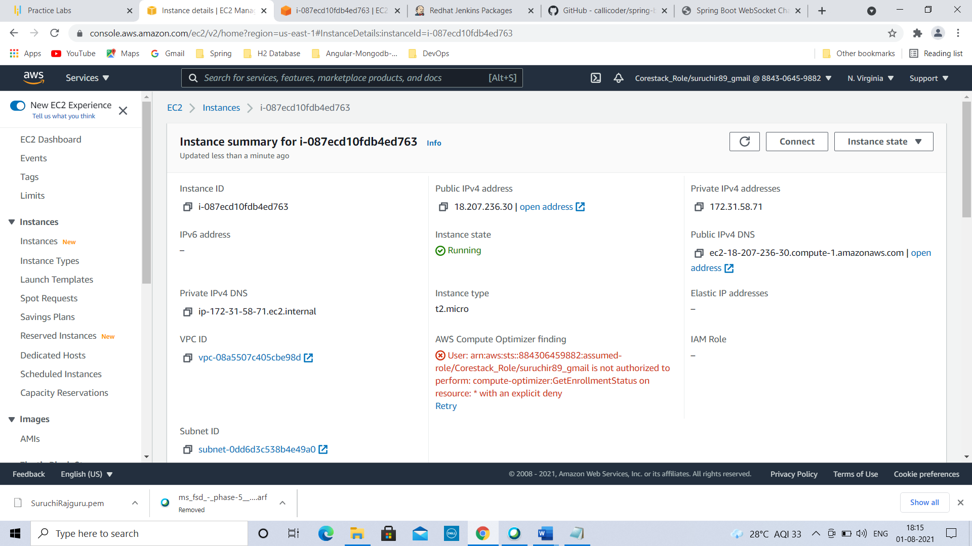

copy address & paste in browser URL followed by colon & port on which you want to run the container

Here it is: 18.207.236.30:8085

Press enter…page is loaded

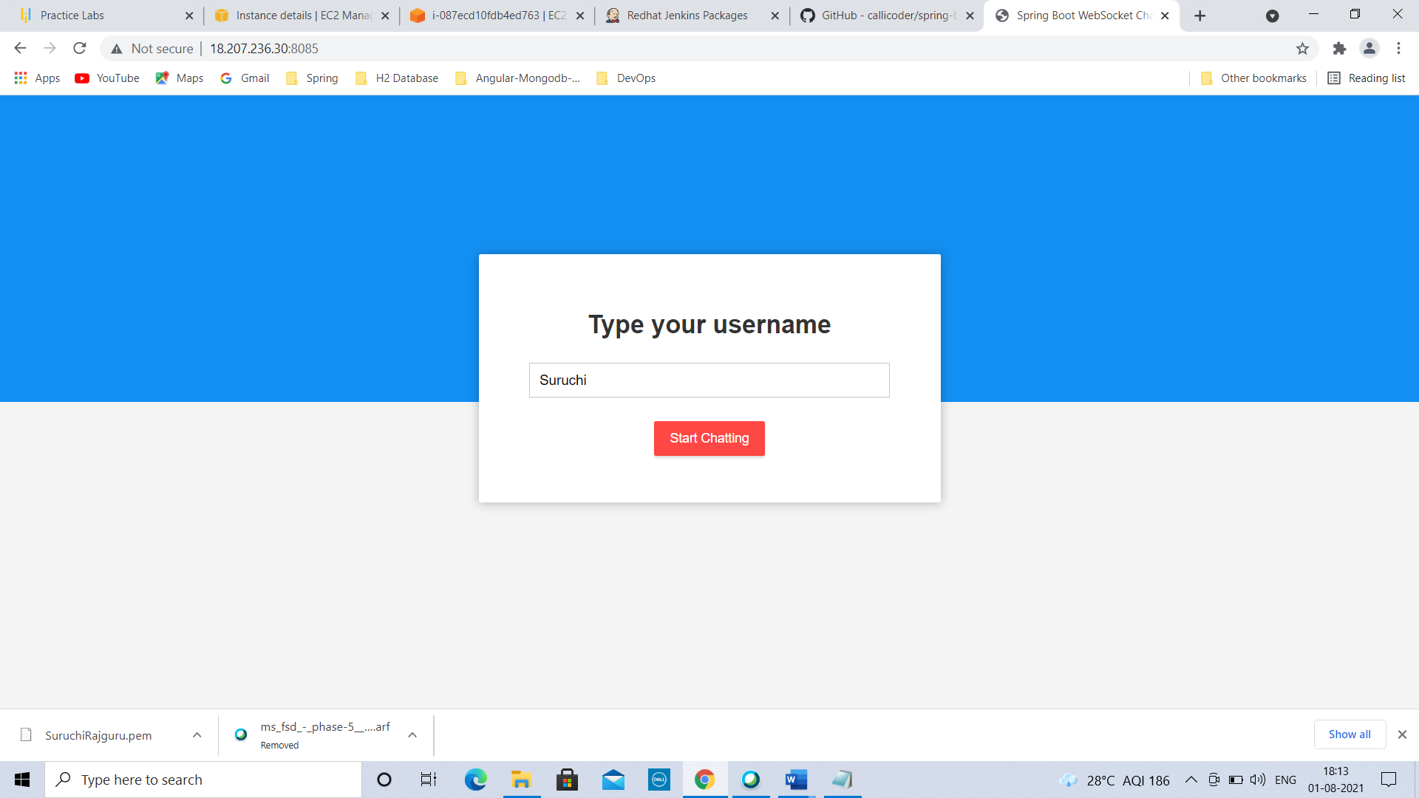

Type your username in the textbox & click on Start chatting button.

Enter your message & press send button.

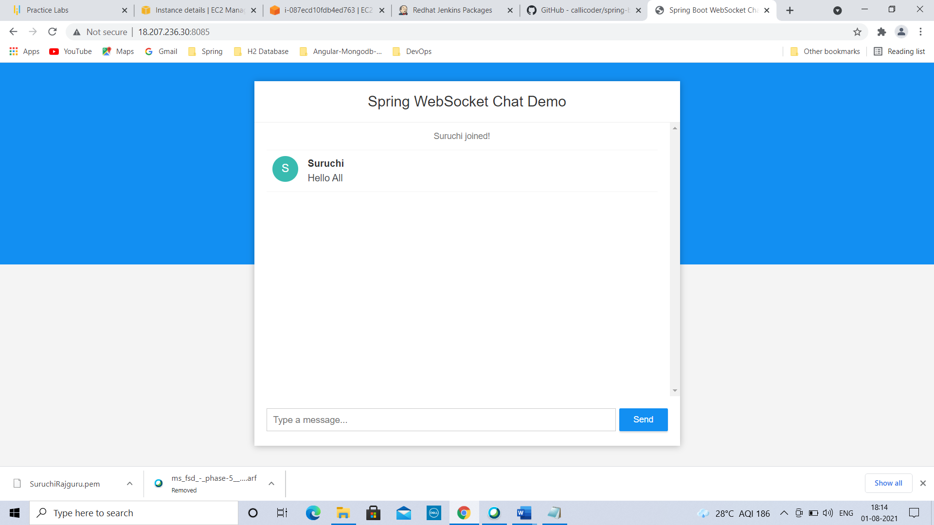

==================================================================================

To open Jenkins website in new browser, type: <https://pkg.jenkins.io/redhat-stable/>

To install Jenkins on EC2 instance, copy following 3 commands & paste inside our instance turn by turn

To get right package to install Jenkins on instance

1)sudo wget -O /etc/yum.repos.d/jenkins.repo <https://pkg.jenkins.io/redhat-stable/jenkins.repo>

(wget means getting something from internet)

To set the key, installing Jenkins as a service

2) sudo rpm --import <https://pkg.jenkins.io/redhat-stable/jenkins.io.key>

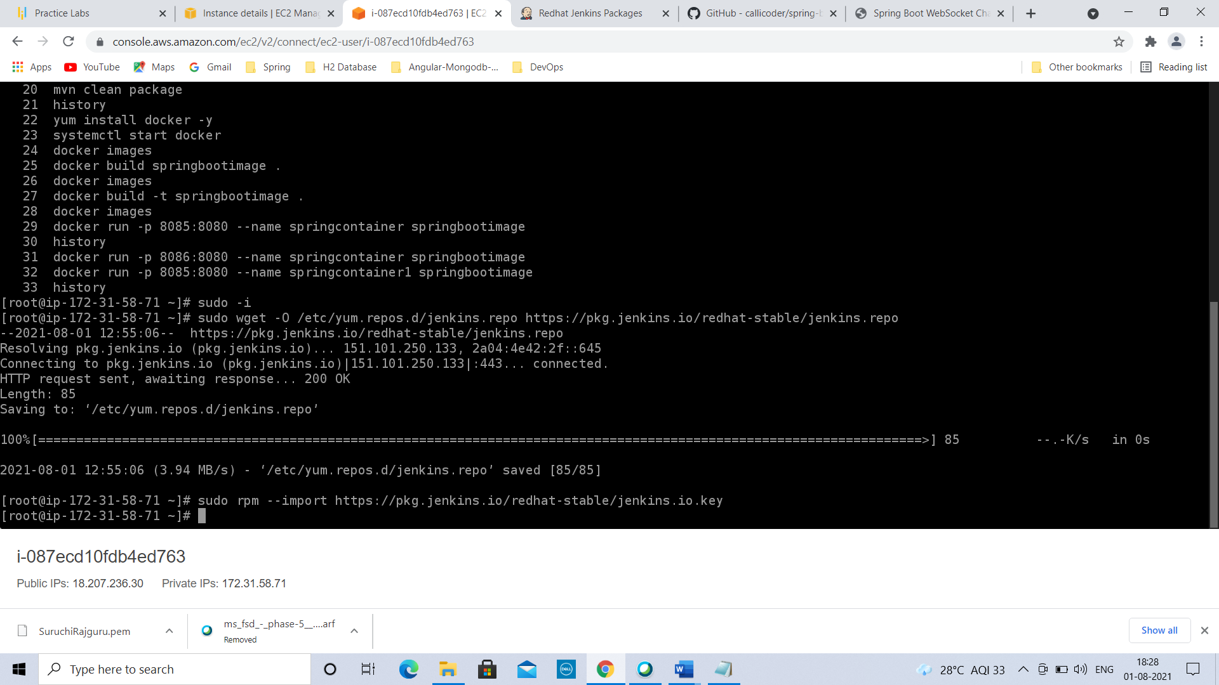

3) yum install Jenkins

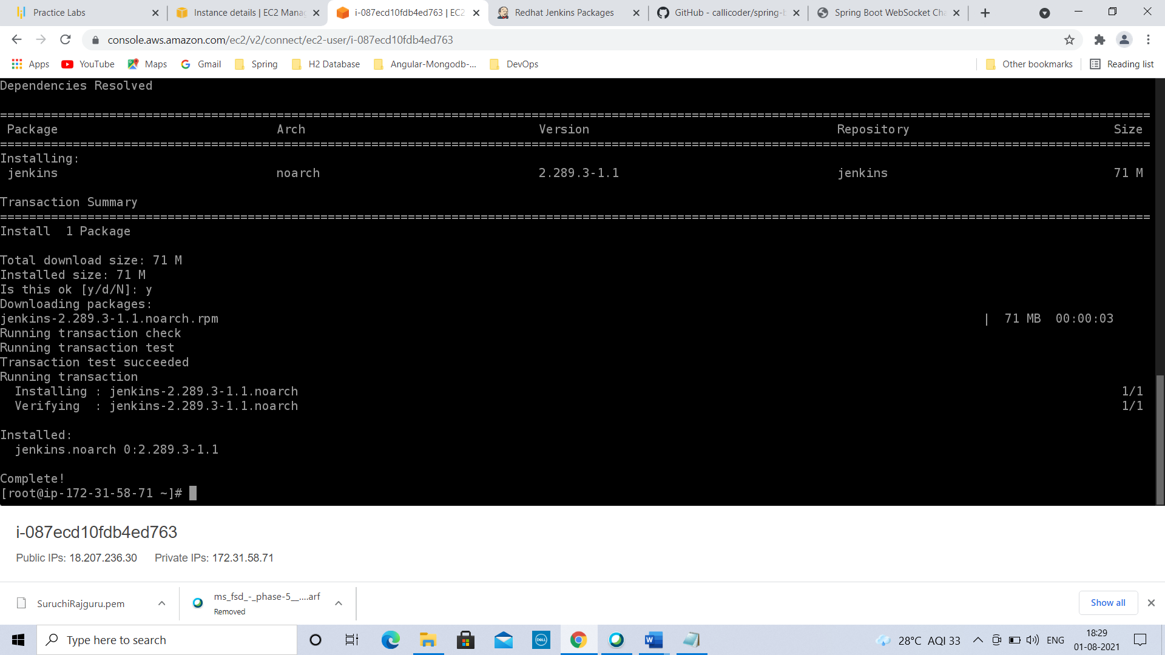

To check history, type: history

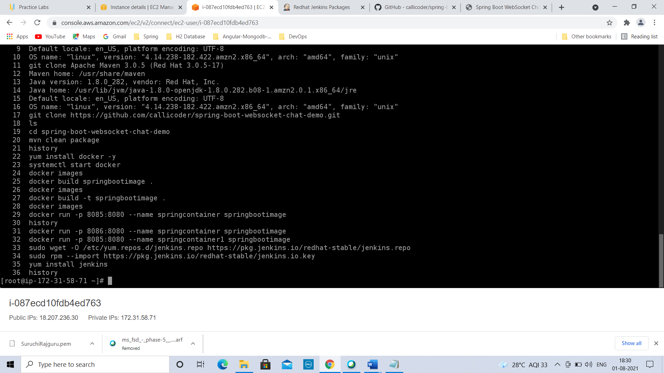

Open new browser tab 🡪 Copy ip address of your machine followed by colon & of default port of Jenkins 8080

After installing service, start Jenkins by typing :

systemctl start Jenkins

Refresh the browser url, it displays getting started page

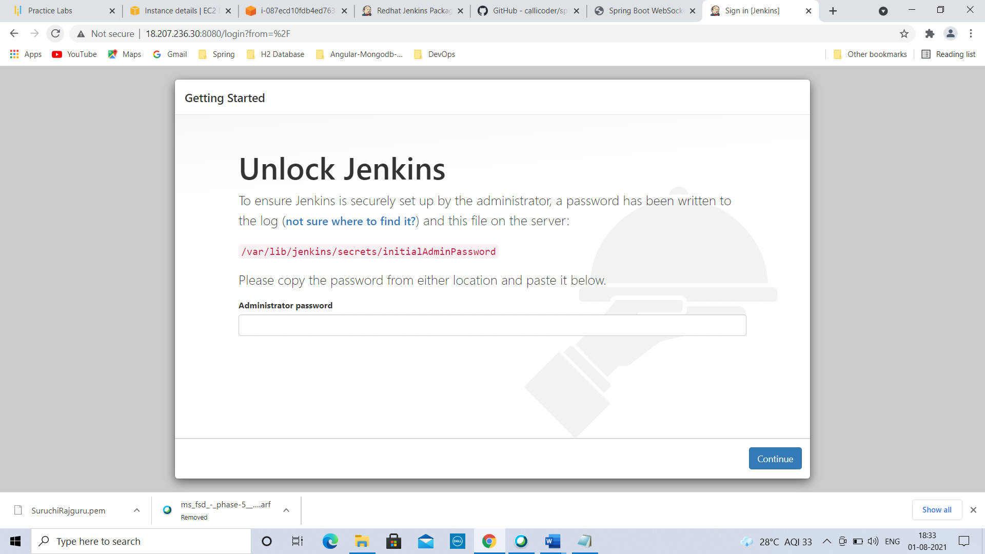

copy path from browser:

/var/lib/Jenkins/secrets/initialAdminPassword

Go to command prompt & type:

cat /var/lib/Jenkins/secrets/initialAdminPassword

Initial password is stored in that location

Copy the password & paste it using (shift+insert) in browser Administrator textbox & click continue.

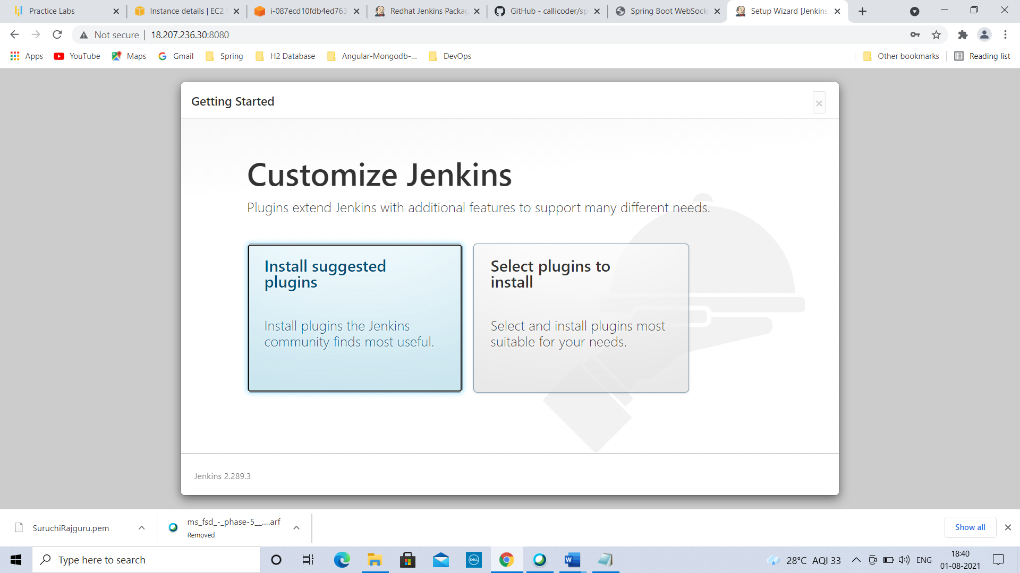

Click on Install suggested plugins🡪 Plugins will be installed.

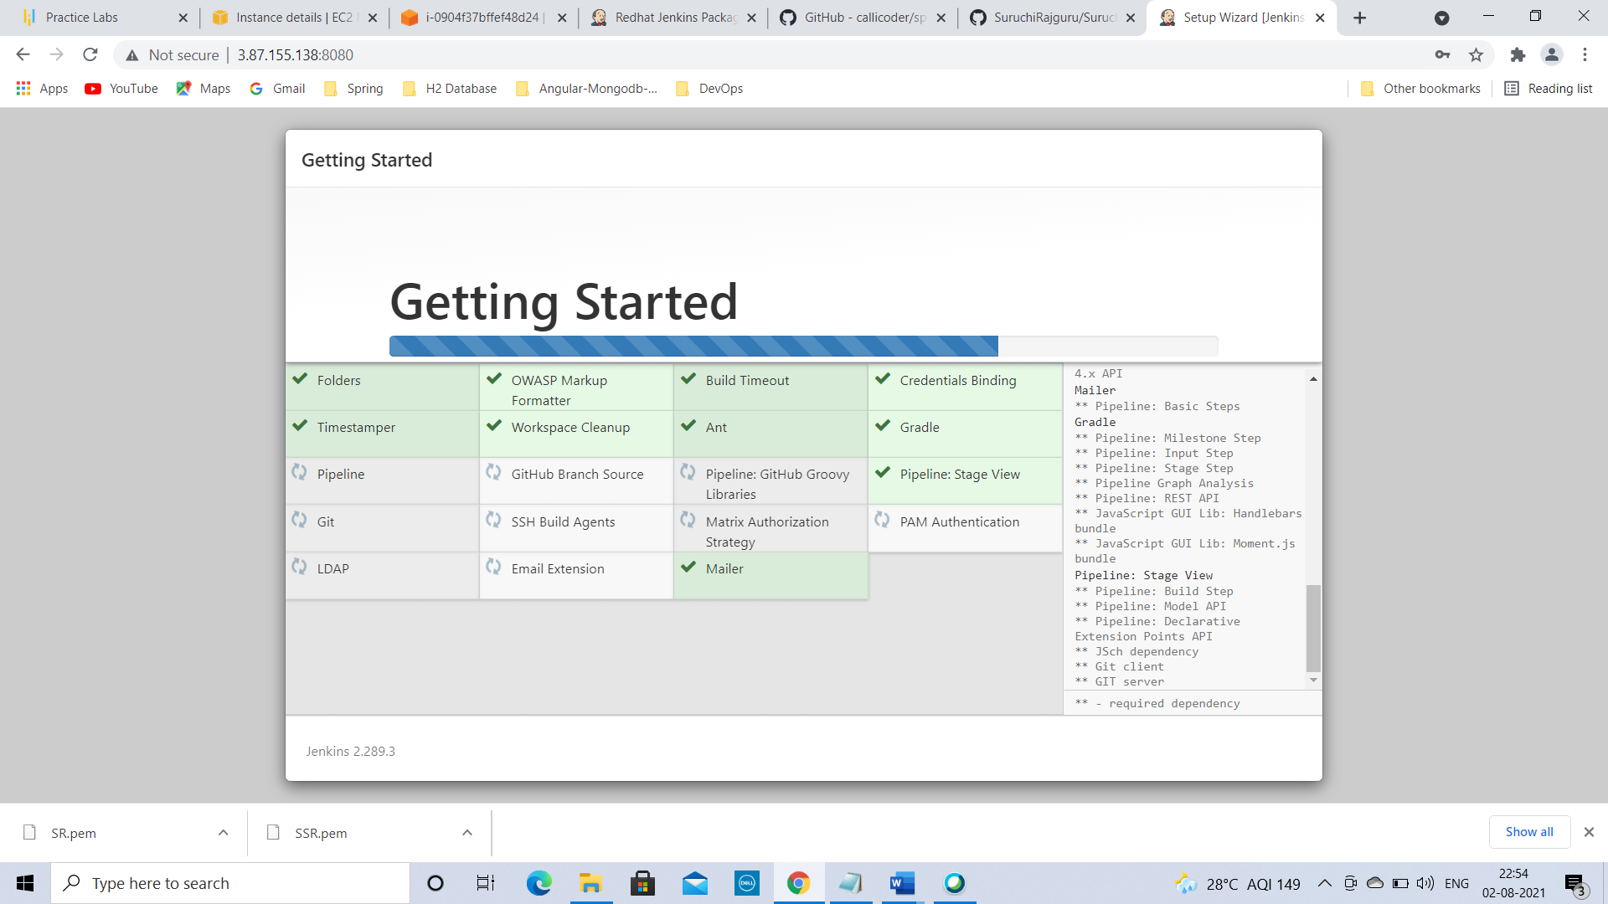

Enter details to Create First Admin User

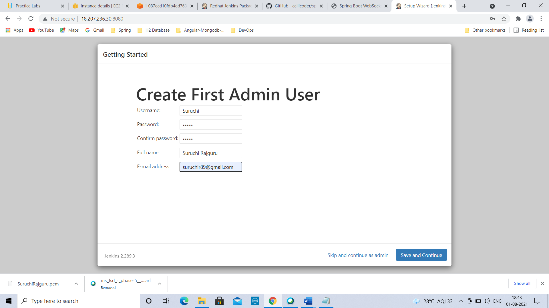

Click on Save & Continue

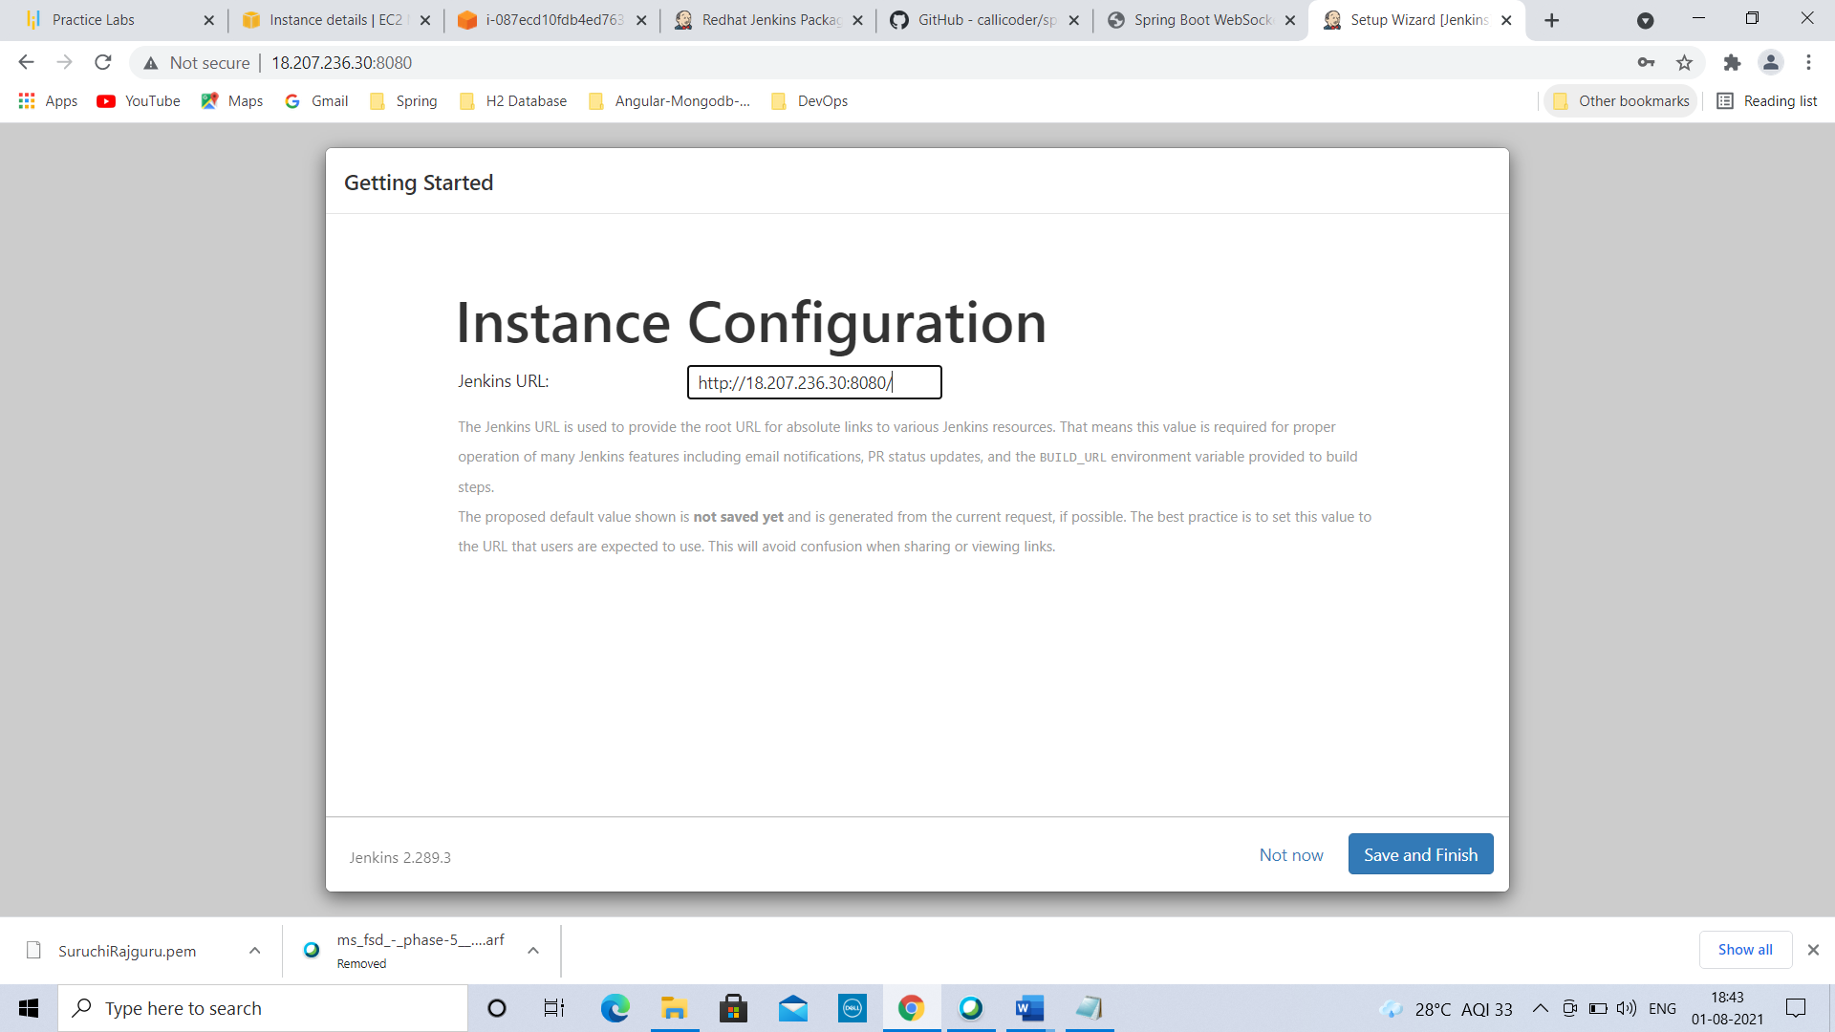

Click on Save & Finish.

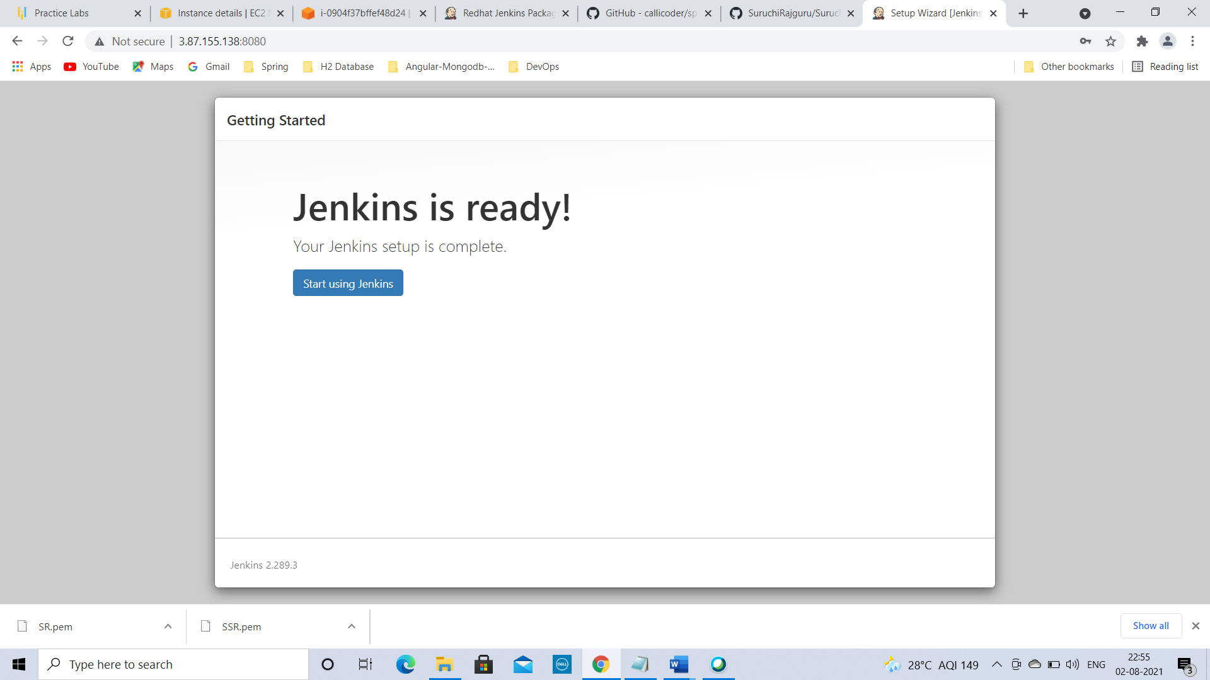

Click on Start using Jenkins.

You are on Jenkins home page.

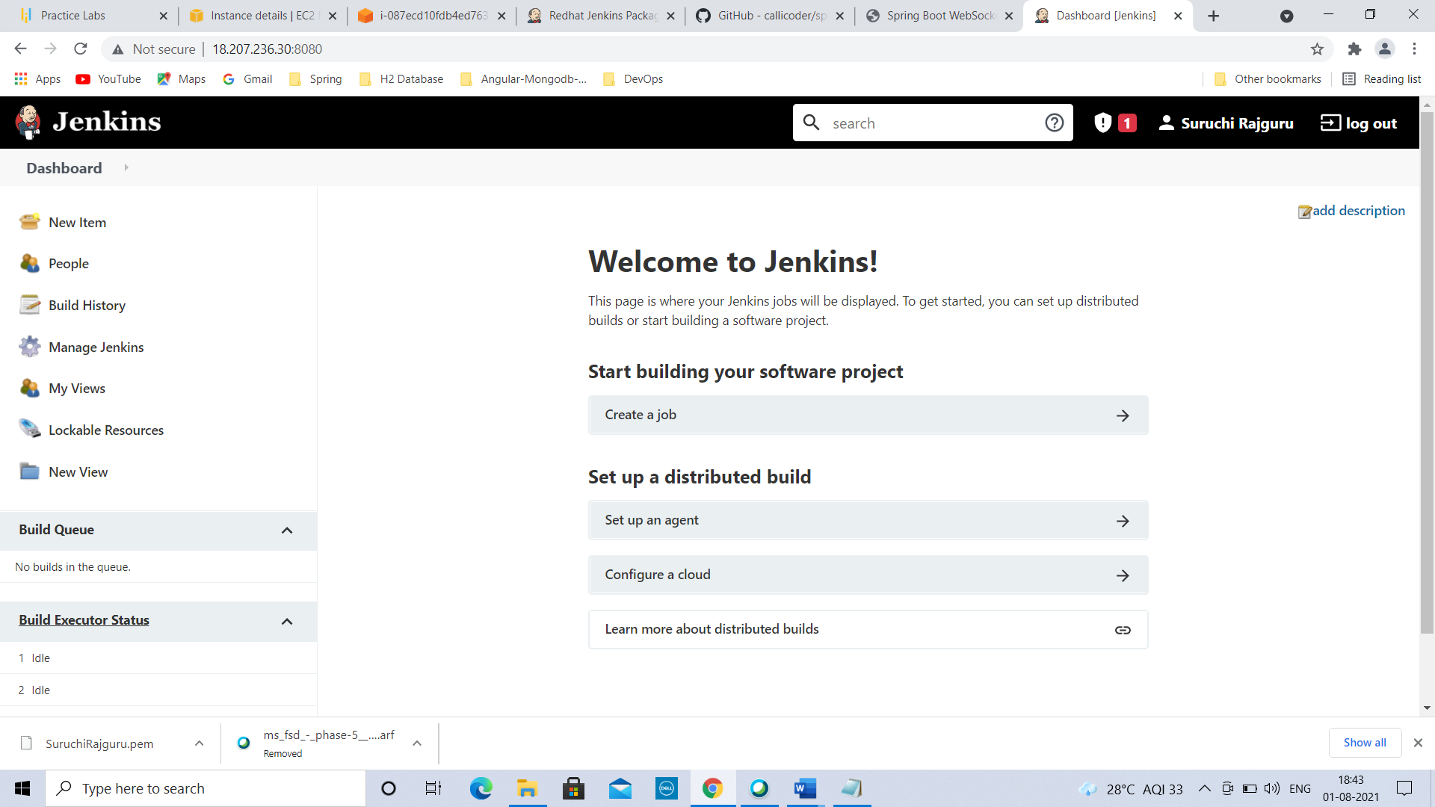

Click on Manage Jenkins-> Manage plugins->

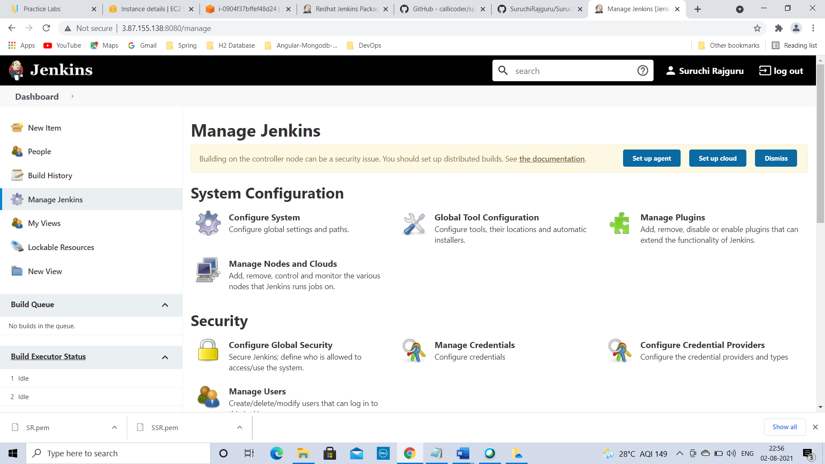

Go to available tab-> search for docker->

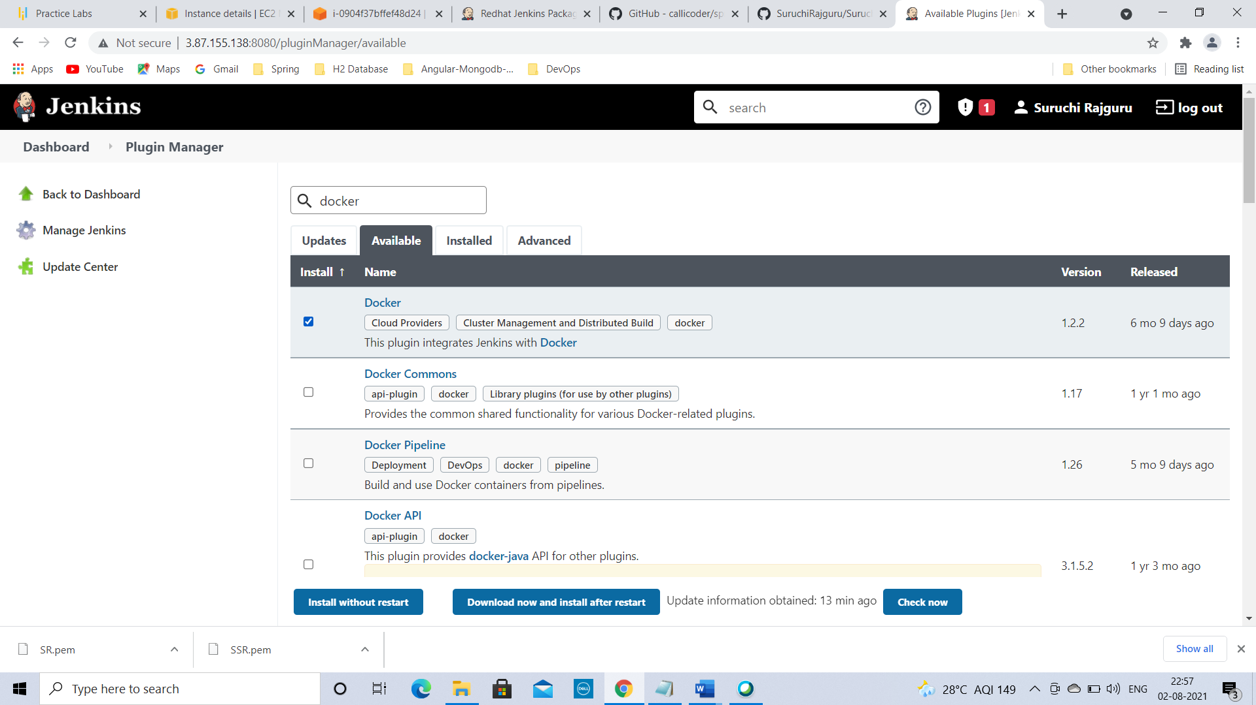

select Docker & install without restart 🡪

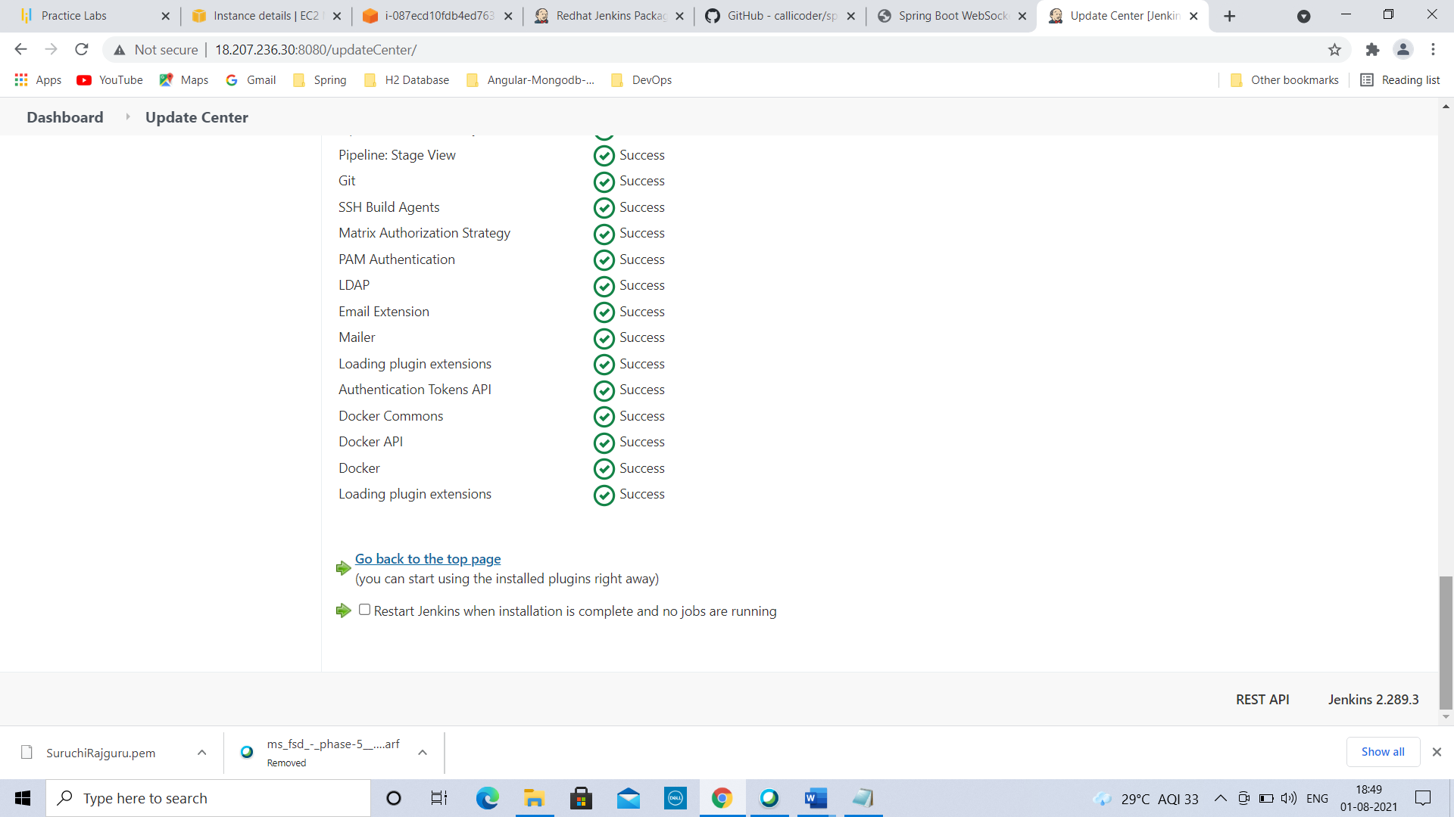

Docker is installed now.

Click on Manage Jenkins 🡪 Global Tool Configuration->

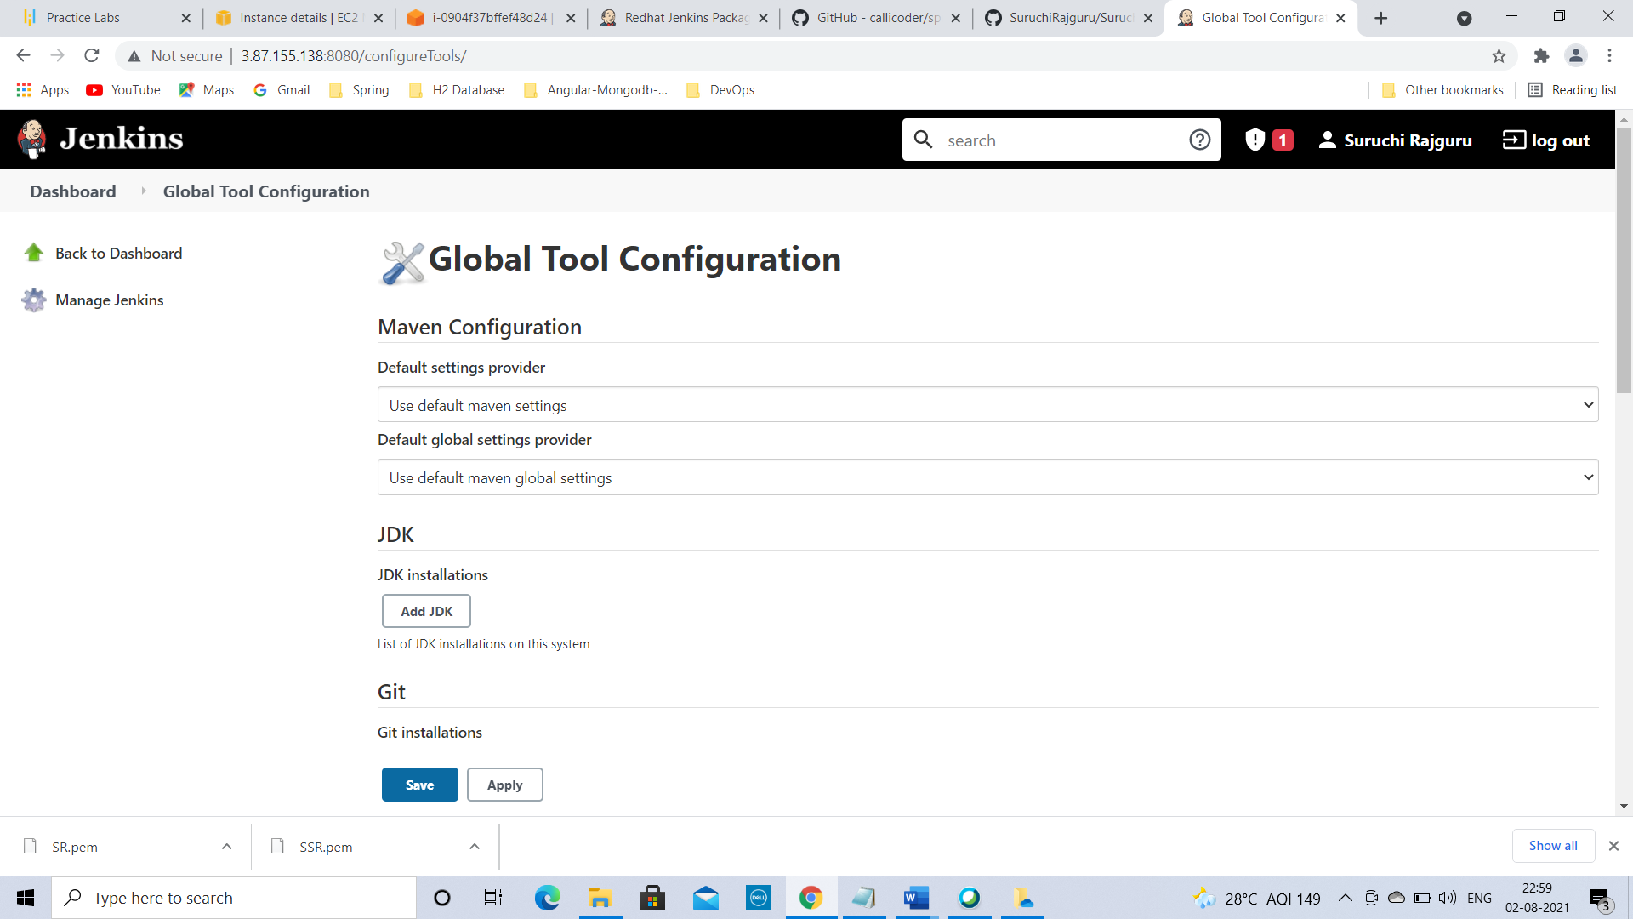

Scroll down on the same page.

Go to Maven->

Click on Add Maven->

Enter the details as below:

Name:M2

Uncheck install automatic

Maven path-/usr/share/maven

(To get maven path…type mvn -version in command prompt.

Copy maven-home:/usr/share/maven----copy paste this from command prompt to Jenkins settings in browser)

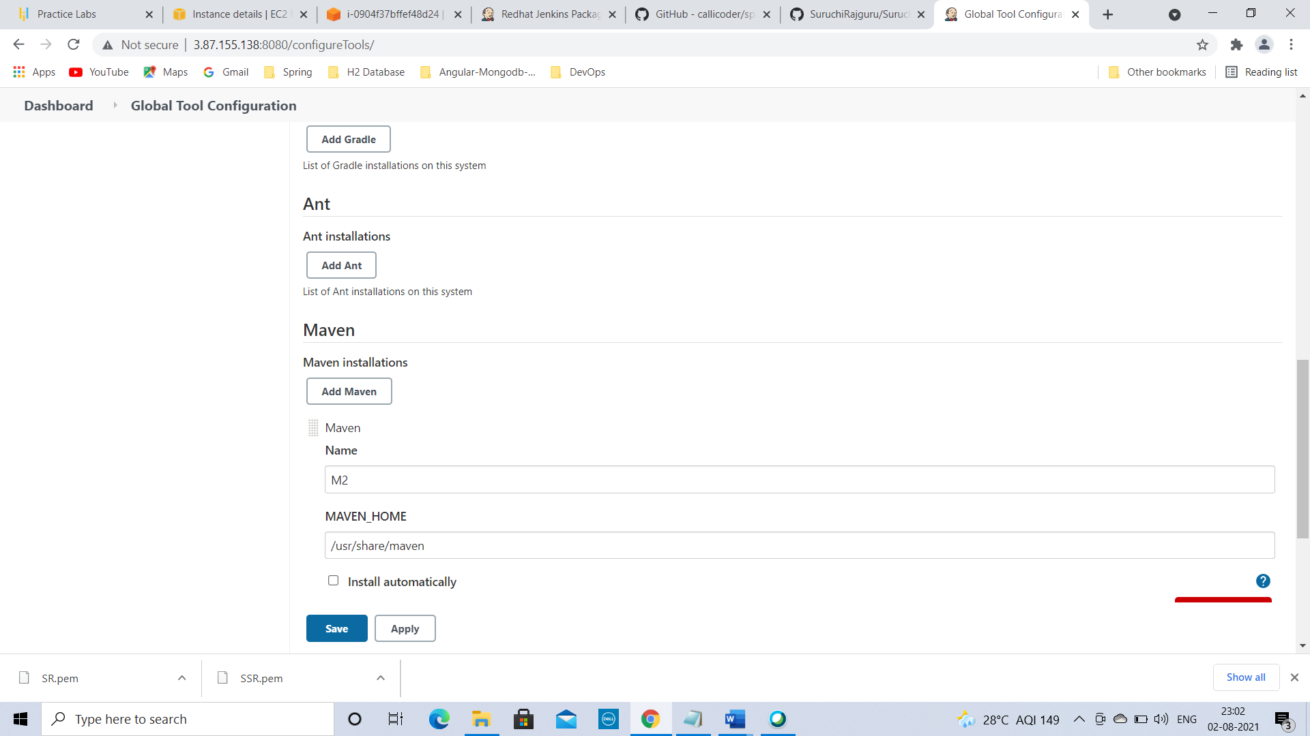

Click on Save 🡪

Go to dashboard->

To create job first:

Click on New Item->

Enter Item Name : Springboot_Job

Select Freestyle project->

Click on OK

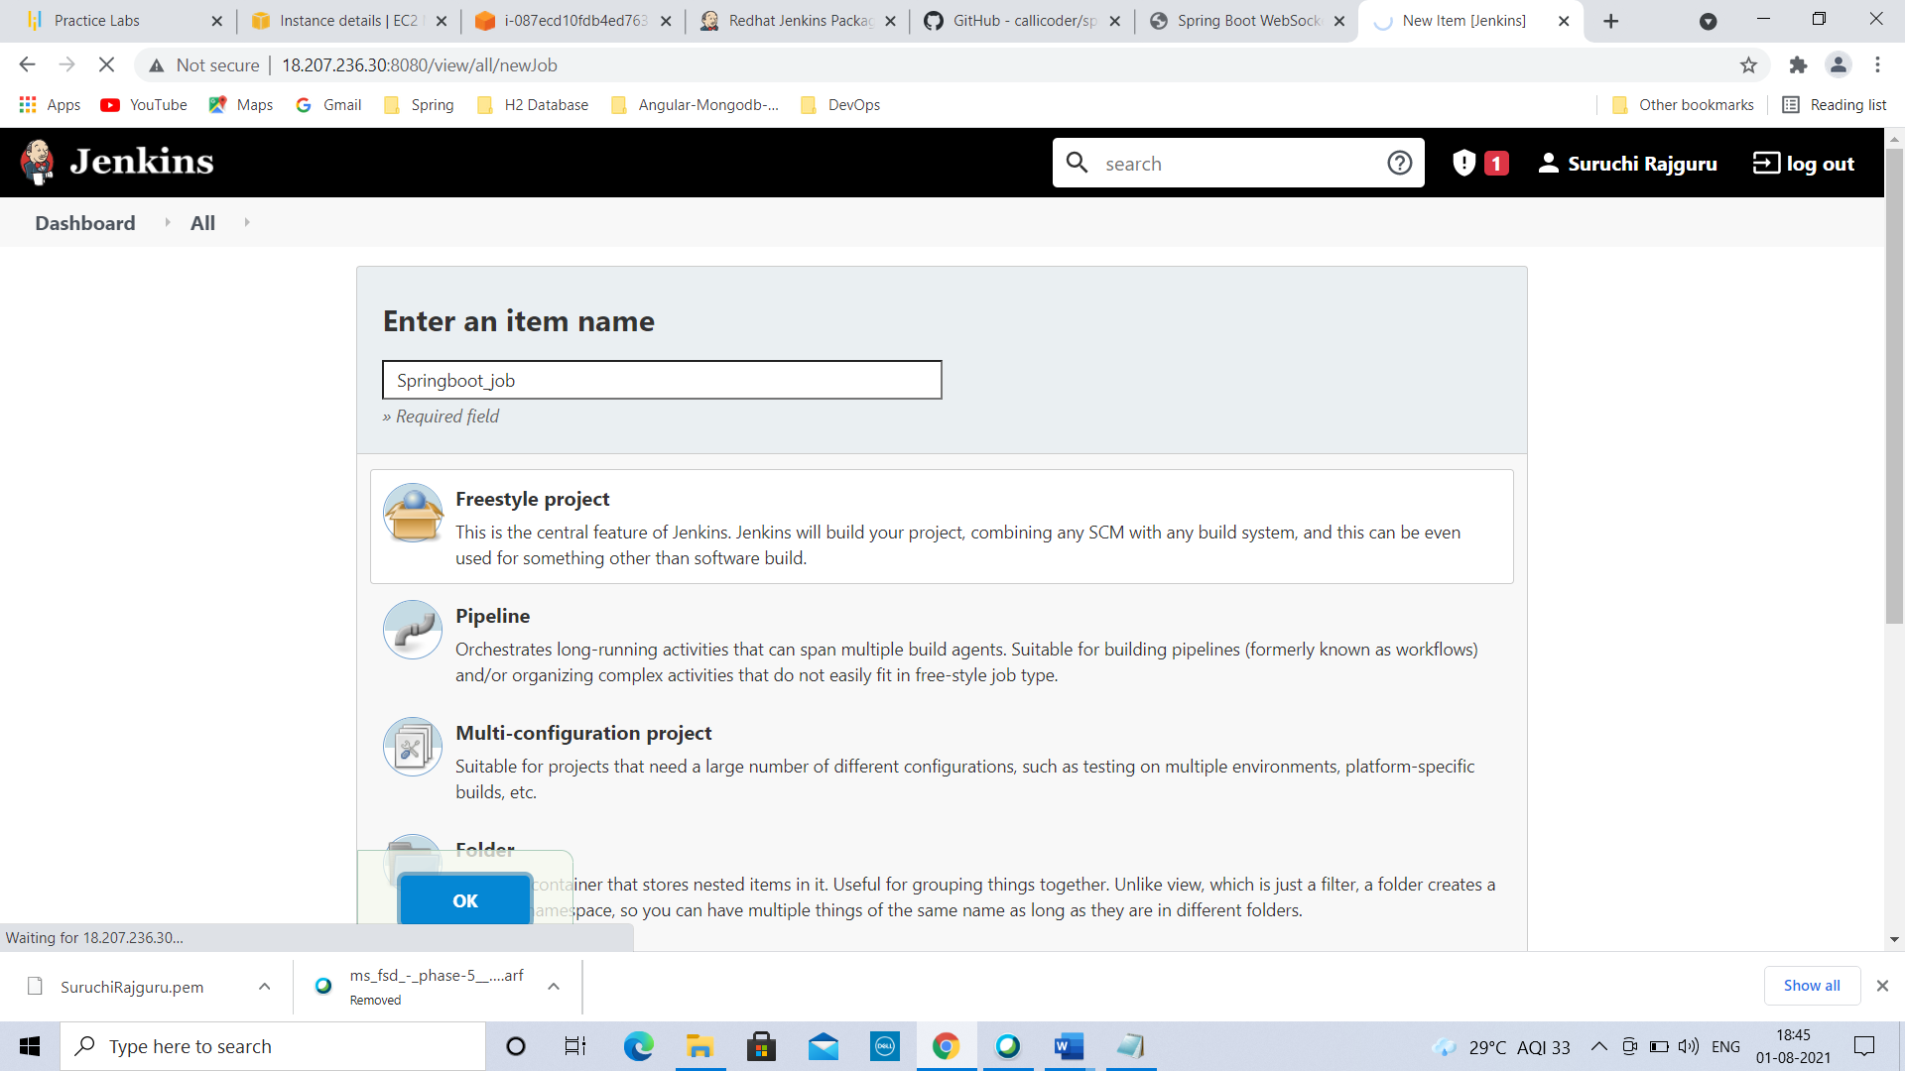

Go to Springboot_Job🡪

Click on Configure ->

Go to Source Code Management->

Select Git radio button🡪

Repositories🡪

Repository URL: https://github.com/callicoder/spring-boot-websocket-chat-demo

(Copy Github url of spring boot application)

Branch specifier: */master

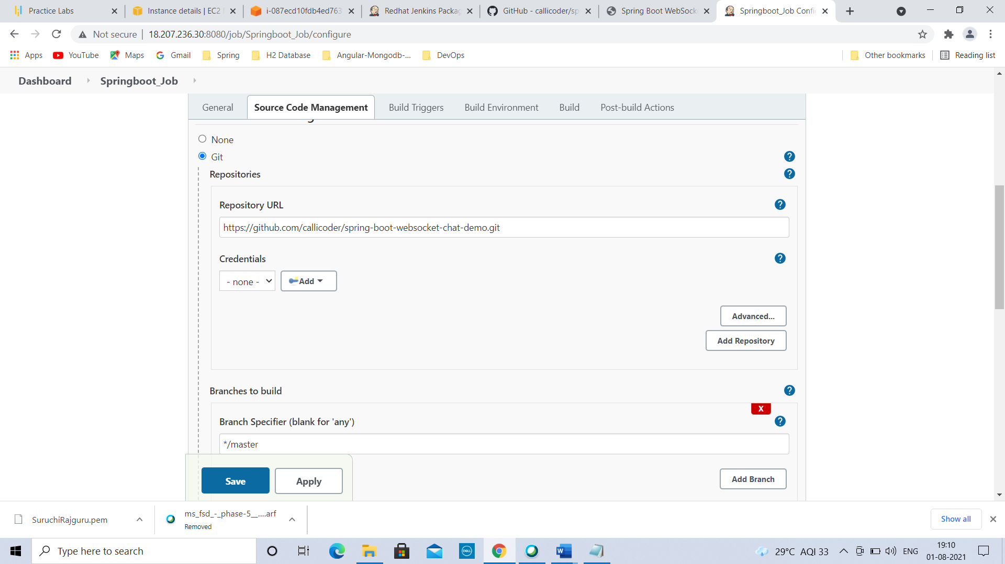

Go to Build Section->

Build 🡪 Add Build Step->Invoke top level Maven targets(select value from dropdown)

Maven version: M2

Goal: package

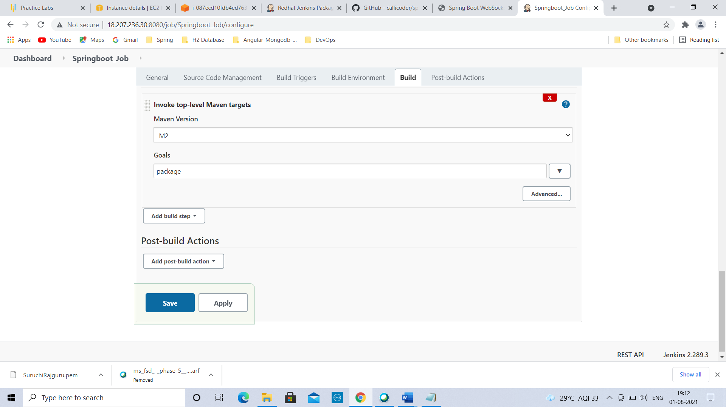

Add build step->Execute shell command->

commands: docker build -t springbootimage .

docker run -p 8089:8080 --name springcontainer1 springbootimage

Click on Save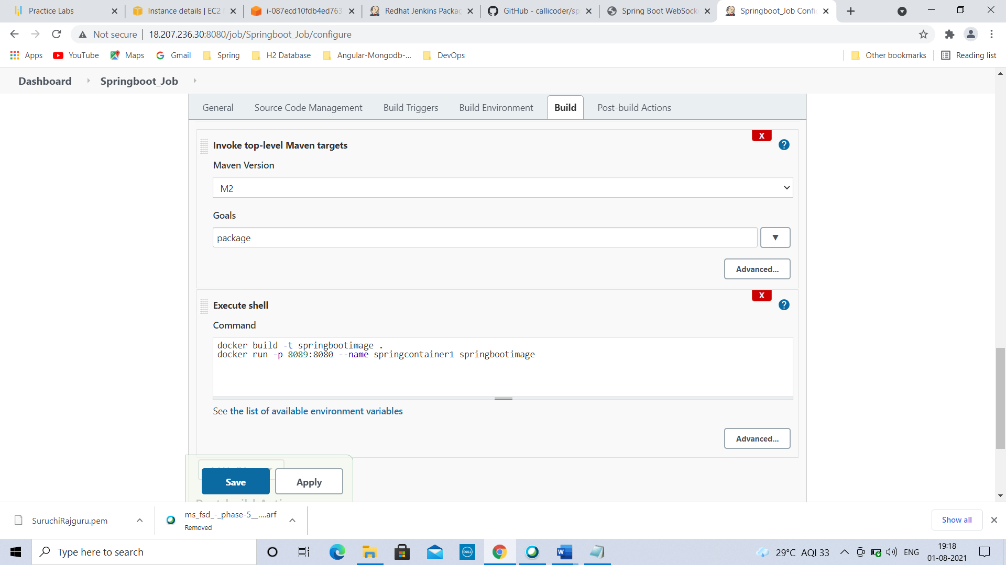

Go to command prompt & type below commands:

sudo -i

sudo usermod -a -G docker Jenkins

sudo service Jenkins stop

sudo service Jenkins start

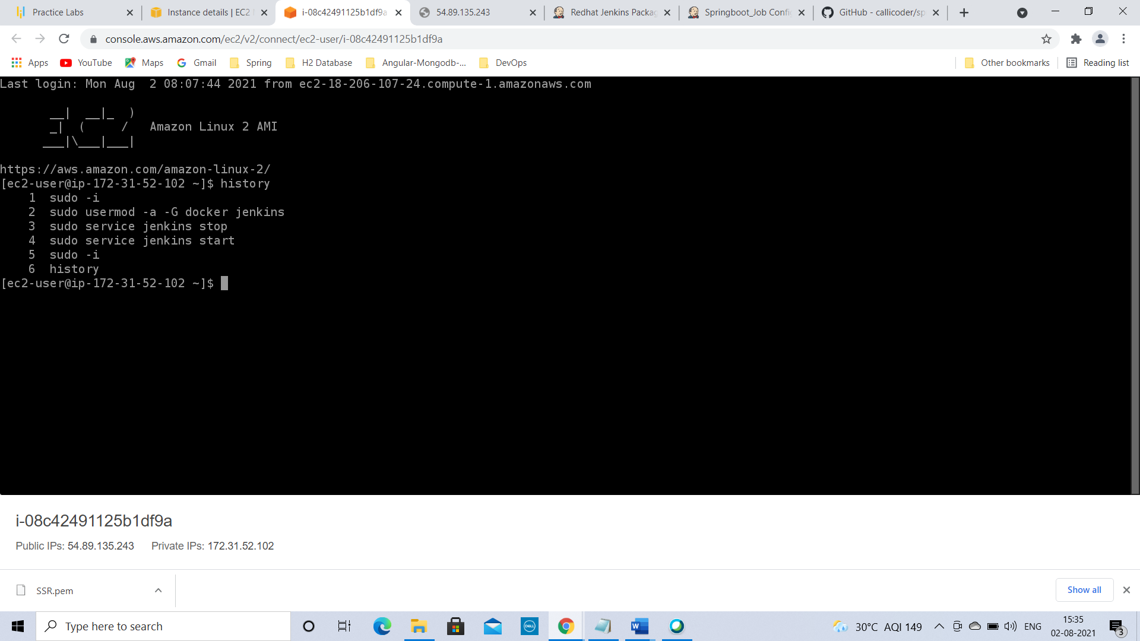

Go to Jenkins tab & Login again

Go to Springboot_Job 🡪 Click on Build Now

Project builds & go to build history🡪 click on recent build 🡪 #12🡪click on Console Output (Application is running)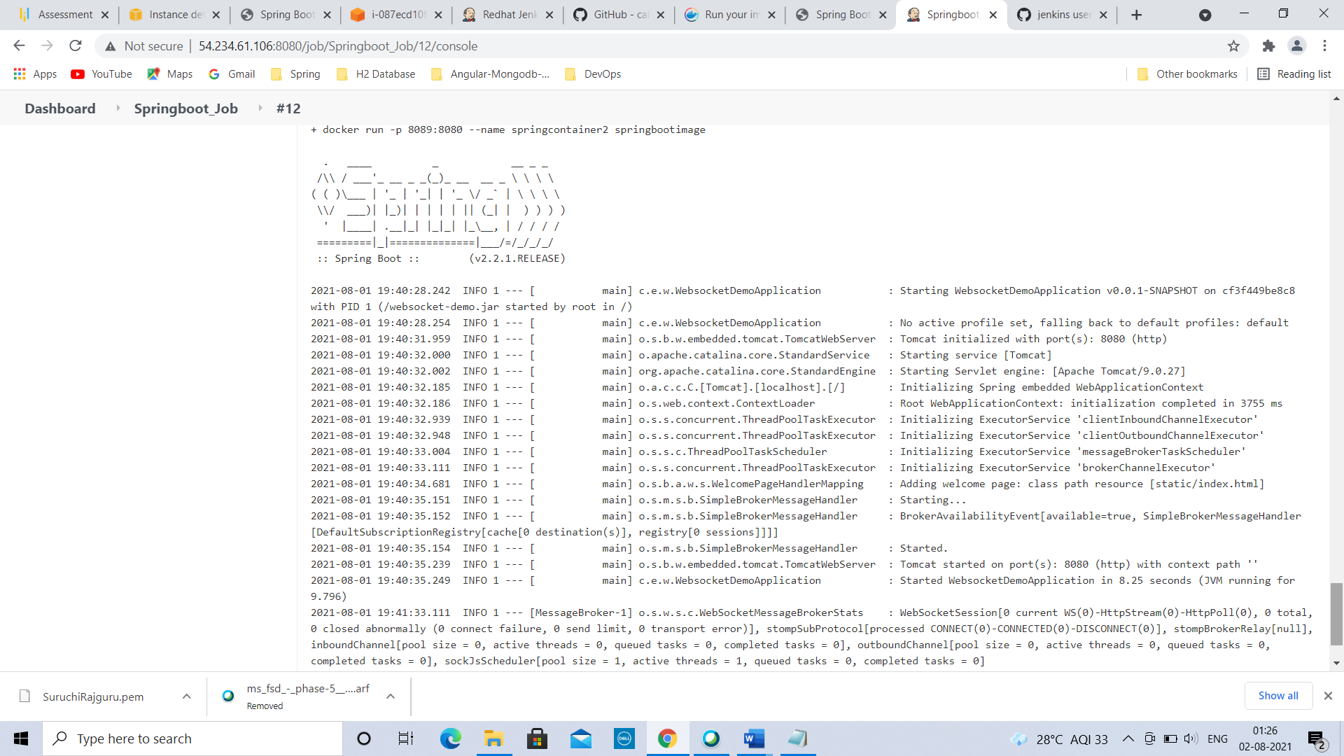

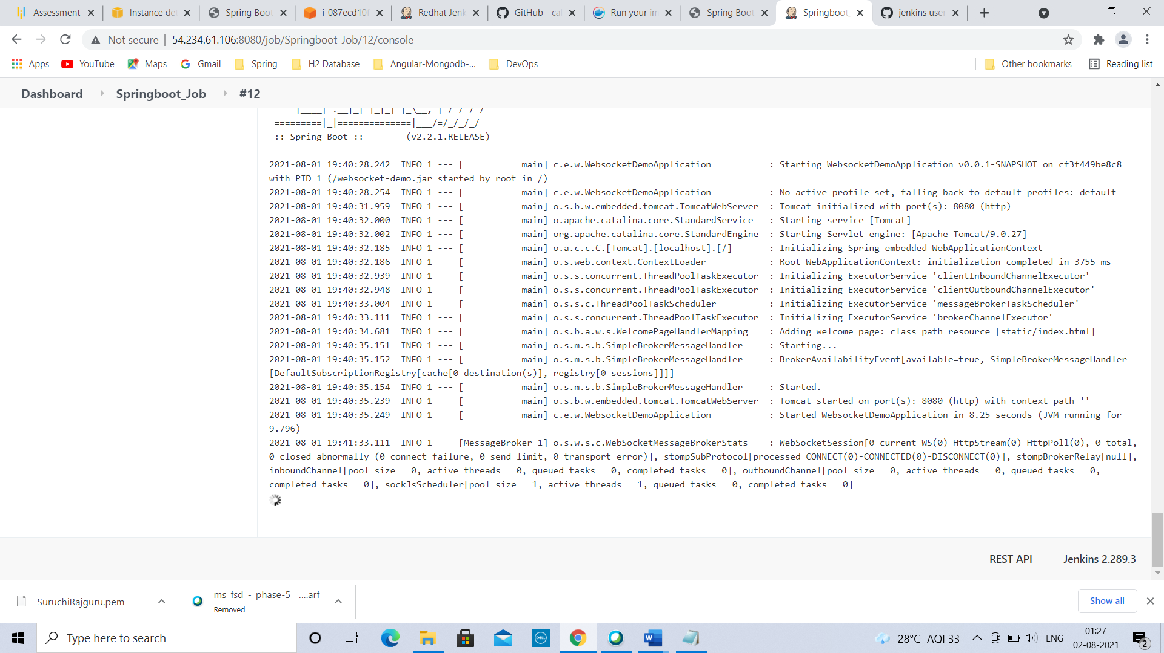

Conclusion: As a Full Stack Developer, successfully built a CI/CD pipeline to demonstrate continuous deployment and host the application on AWS EC2 instance.

Successfully automated the integration and deployment of the web application.

As the source code is supposed to be fetched from a GitHub repository, Github link of the project is : <https://github.com/callicoder/spring-boot-websocket-chat-demo.git>

Technologies used:

1. GitHub 2) Jenkins 3) AWS EC2/ Virtual machine